MODEL NO. KOR-6L77

MICROWAVE OVEN USER MANUAL

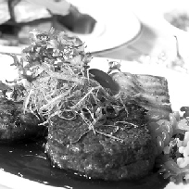
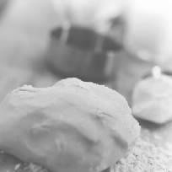
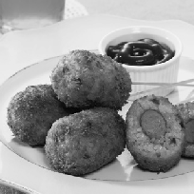
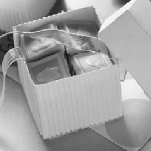

Customer Helpline Number : 0844 887 2525
Spare Parts : 0844 557 0290 or www.4daewoo.co.uk / DAEWOO ELECTRONICS Web Site www.daewooelectronics.co.uk

Table of contents

About Your Microwave
Introduction 03
Before first use 04
Features diagram 05
Operation procedure 06
Safety
Important Safety Instructions 07
Electrical Connection 09
Cleaning 10
Trouble Shooting 11
Question And Answer 12
Technical Data
Specifications 13
Disposal of used electrical & electronic equipment 14

»INTRODUCTION
You have chosen a Daewoo Microwave Oven.
Daewoo offers a variety of quality products that would make your life more comfortable.
This microwave oven combines the properties of a microwave with those of a traditional oven.
Please read the user manual very carefully before starting to use the appliance. Just for your information, the manual also serves as cooking recipe.
Enjoy cooking!

»Before first use
- Put the microwave on a solid, flat surface.
- Ensure that there is adequate ventilation around the microwave. Keep 30 cm of space free at the top. At the back and sides,
keep at least 7.5 cm free.
- Do not cover the ventilation openings. Do not forget to remove protective film, if applied.
- The adjustable feet may not be removed.
- Do not place the microwave in the vicinity of heat sources.
- Broadcasting and transmitting equipment such as radios and TVs can affect the working of the microwave.
- Remove the accessories from the microwave and clean them with a mild cleaning agent. Then put the frame back on the shaft.

30 cm
7.5 cm
7.5 cm

7.5 cm

NOTE
When you heat the microwave to a high temperature for the first time, you will notice a ‘new-oven smell’.
Don’t worry, this is normal. If desired, switch on the cooker hood or open a window.
The minimum height of free space necessay above the top surface of the oven is minimum 170mm.

»Features diagram

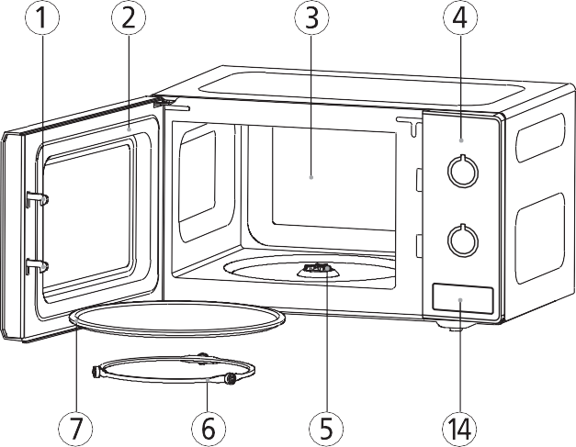
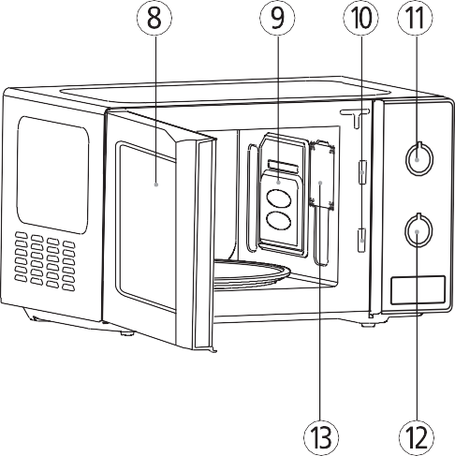

- Door latch - When the door is closed, it will automatically shut off. If the door is opened while the oven is operating, the magnetron will automatically shut off.
- Door seal - The door seal surfaces prevent microwaves escaping from the oven cavity.

Oven cavity
- Control panel
- Coupler - This fits over the shaft in the center of the oven cavity floor. This is to remain in the oven for all cooking.
- Roller guide - This must always be used for cooking together with the glass cooking tray.
- Glass cooking tray - Made of special heat resistant glass. The tray must always be in proper position before operating. Do not cook food directly on the tray.

- Viewing screen - Allows viewing of food.
The screen is designed so that light can pass through, but not the microwave.
- Waveguide cover - Protects the microwave outlet from splashes of cooking foods.
- Safety interlock system
- Variable power control knob - Used to select a microwave power level.
- Timer knob - Used in setting cooking time for all functions.
- Oven lamp - Automatically turns on during oven operating.
- Door opening button

»Operation procedure

This section includes useful information about oven operation.

- Plug power supply cord into 230V AC 50Hz power
outlet.

- After placing the food in a suitable container, open the oven door and put it on the glass tray.
The glass tray and roller guide must always be in place during cooking.

- Close the door. Make sure that it is firmly closed. The oven door can be opened at any time during operation by pulling the door. The oven will automatically shut off.

- Set the variable power control knob to the desired power level.
SYMBOL | POWER LEVEL | OUTPUT POWER
 | Gentle heating | 117W
 | Heat | 187W
 | Defrost | 306W
 | Low stage | 385W
 | Medium | 541W
 | Medium high | 658W
 | High | 700W

- Set the operating time by turing the timer knob to the desired cook time and the microwave cooking starts.
  - If setting the timer control for less than
2 minutes, turn it past 2 minutes and then back to the desired time.
- Microwave energy will be turned off automatically when the timer knob reaches “OFF”. Then food can be taken out of the oven.
  - To prevent the oven from operating with the door open, your microwave oven is fitted with safety door interlock switches.
  - If you wish to inspect the food while it is cooking simply open the door. The oven will automatically stop cooking. To continue cooking, you simply close the door.
  - If you wish to stop cooking, simply turn the timer knob to the “OFF” position. Cooking can be reset at any time during the cooking cycle by turning the timer control.
  - Do not let the timer continue to operate when
there is no food inside.

IMPORTANT SAFETY INSTRUCTIONS
READ CAREFULLY AND KEEP FOR FUTURE REFERENCE.
WARNING : To prevent fire, burns, electric shock and other warnings:
Listed below are, as with all appliances, certain rules to follow and safeguards to assure high performance from this oven:

- Do not use the oven for any reason other than food preparation, such as for drying clothes, paper, or any other
nonfood items or for sterilizing purposes.
- Do not use the oven when empty, this could damage the oven.
- Do not use the oven cavity for any type of storage, such as papers, cookbook, cookware, etc.
- Do not operate the oven without the glass tray in place. Be sure it is properly sitting on the rotating base.
- Make sure you remove caps or lids prior to cooking when you cook food sealed in bottles.
- Do not put foreign material between the oven surface and door. It could result in excessive leakage of microwave energy.
- Do not use recycled paper products for cooking. They may contain impurities which could cause sparks and/or fires when used during cooking.
- Do not pop popcorn unless popped in a microwave approved popcorn popper or unless it's commercially packaged and recommended especially for microwave
ovens. Microwave popped corn produces a lower yield than conventional popping; there will be a number of unpopped kernels. Do not use oil unless specified by the manufacturer.
- Do not cook any food surrounded by a membrane, such as egg yolks, potatoes, chicken livers, etc., without first piercing them several times with a fork.
- Do not pop popcorn longer than the manufacturer's directions. (popping time is generally below 3 minutes). Longer cooking does not yield more popped corn, it can cause scorchings and fire. Also, the cooking tray can become too hot to handle or may break.
- If smoke is emitted, switch off or unplug the appliance and keep the door closed in order to stifle any flames.
- When heating food in plastic or paper containers, keep an eye on the oven due to the possibility of ignition.

- The contents of feeding bottles and baby food jars shall be stirred or shaken and the temperature checked before consumption, in order to avoid burns.
- Always test the temperature of food or drink which has been heated in a microwave oven before you give it to somebody, especially to children or elderly people. This is important because things which have been heated in a microwave oven carry on getting hotter even though the
microwave oven cooking has stopped.
- Eggs in their shell and whole hardboiled eggs should not be heated in microwave ovens since they may explode, even after microwave heating has ended;
- Keep the waveguide cover clean at all times. Wipe the oven interior with a soft damp cloth after each use. If you leave grease or fat anywhere in the cavity it may overheat, smoke or even catch fire when next using the oven.
- Never heat oil or fat for deep frying as you cannot control the temperature and doing so may lead to overheating and fire.
- Microwave heating of beverages can result in delayed eruptive boiling, therefore care must be taken when handling the container.
To reduce the risk of injury to persons:
- Do not overheat the liquid.
- Stir the liquid both before and halfway through heating it
- Do not use straight-sided containers with narrow necks.
- After heating, allow the container to stand in the microwave oven for a short time before removing the container.
- Use extreme care when inserting a spoon or other utensil into the container.
- This appliance is not intended for use by persons(including children) with reduced physical, sensory or mental capabilities, or lack of experience and knowledge, unless they have been given supervision or instruction concerning use of the appliance by a person responsible for their safety.
- Children should be supervised to ensure that they do not play with the appliance.
- Only use utensils that are suitable for use in microwave ovens.
- During use the appliance becomes hot. Care should be taken to avoid touching heating elements inside the oven.
- Do not use a steam cleaner in the oven.

SAVE THESE INSTRUCTIONS

»Electrical Connection
WARNING-THIS APPLIANCE MUST BE EARTHED.

REFER TO RATING PLATE FOR VOLTAGE AND CHECK THAT THE APPLIANCE VOLTAGE CORRESPONDS WITH THE SUPPLY VOLTAGE IN YOUR HOME.
The flexible mains lead must be correctly connected, as below, to a three pin plug of not less than 13 AMP capacity. You must use a 3 pin plug which should be marked with the number BS 1363 and it should be fitted with 13 AMP fuse marked with the number BS 1362. We recommend the use of good quality plugs and wall sockets that can be switched off when the machine is not in use.

Power supply
- Check your local power source. This oven requires a current of approximately 15amperes, 230V 50Hz.
- Power supply cord is about 1.2 meters long.
- The voltage used must be the same as specified on this oven. Using a higher voltage may result in a fire or other accident causing oven damage. Using low voltage will cause slow cooking. We are not responsible for damage resulting from use of this oven with a voltage of ampere fuse other than those specified.
- If the supply cord is damaged, it must be replaced by the manufacturer or its service agent or a similarly qualified person in order to avoid a hazard.
IMPORTANT-The wires in the mains lead fitted to this appliance are coloured in accordance with the following code
GREEN AND YELLOW-EARTH BLUE-NEUTRAL
BROWN-LIVE
As the colour of the wires in the mains lead of this appliance may not correspond with the coloured markings identifying the terminals in your plug, proceed as follows:
The wire which is coloured GREEN AND YELLOW must be connected to the terminal in the plug which is marked with the letter "E" or the earth symbol or coloured GREEN AND YELLOW, or GREEN.
The wire which is coloured BLUE must be connected to the terminal which is marked with the letter "N" or coloured BLACK, or BLUE.
The wire which is coloured BROWN must be connected to the terminal which is marked with the letter "L" or coloured RED , or BROWN.
If the terminals in the plug are unmarked or you are in any doubt as to the correct connections, consult a qualified electrician.
If you do not make the proper electrical connections you will damage your microwave oven and possibly injure yourself. Neither the manufacturer nor the supplier are liable if this happens.

MOULDED PLUGS
Should it be necessary to remove a moulded on plug from the mains cable, it should be cut off and replaced with a suitable replacement.
The moulded plug cannot be used for any other appliance, therefore remove the fuse and dispose immediately and safely to prevent anyone, especially children from plugging it in to a wall socket, which will create a safety hazard.
Should the mains lead ever require replacement, it is essential that this operation be carried out by a qualified electrician and should only be replaced with a flexible cord obtained from the manufacturer.
Applicable only if moulded plug is fitted.
After replacement of a fuse in the plug, the fuse cover must be refitted. If the fuse cover is lost, a replacement cover is obtained. The colour of the correct replacement fuse cover is that of the coloured insert in the base of the plug or the colour that is embossed in words in the base of the plug recess or elsewhere on the plug. Always state this colour when ordering a replacement fuse cover. Only 13 amp replacement fuses which are ASTA approved to BS 1362 should be fitted

- The oven must always be clean. Residue of food from spillovers or spatters will attract microwave energy causing it to burn on. This could reduce the efficiency of the oven and may cause bad odours.
- DO NOT USE any abrasive cleaners or metal scrapers to clean the glass door. This will scratch the surface which can break the glass.
- DO NOT USE high pressure cleaners or
steam cleaners to clean the microwave.
- Clean the interior directly after use. Use a damp cloth to remove condensation, boiled over liquid and food remnants.
Remnants of crumbs and moisture absorb microwave energy and increase cooking time.
- Clean the interior and outer casing regularly; use some washing-up liquid and water and dry the microwave well with a dry cloth.
- Ensure that the cover of the microwave distributor is clean. Dirt in the cover can lead to spark formation.
- Clean the accessories regularly; use some washing-up liquid and water with a brush and dry the accessories well with a dry cloth. The accessories may also be washed in the dishwasher.
- Smells will disappear if you place a glass of vinegar or water with lemon in the microwave area. Switch the microwave on at full power for two minutes. Then
rub down with a damp cloth.
  - Check the door closure and the door rubber regularly for damage. Do not use the microwave if the door or door closure is damaged.
  - If the seal of the microwave is very dirty, the door won't close properly. The front of adjacent furniture can become damaged. Keep the seal clean.
  - Salt is extremely aggressive. When this is deposited in the oven interior, rust patches can be created.
  - Spicy sauces such as ketchup and mustard or salty dishes such as salted meat contain ingredients that can erode the surface. After use, you should always clean the oven interior.
  - DO NOT USE ANY TYPE OF OVEN CLEANER ON ANY PART OF THE OVEN.
It will damage some of the interior and exterior surfaces of the oven.
  - The oven should be cleaned regularly and any food deposits removed.
  - Failure to maintain the oven in a clean condition could lead to deterioration of the surface that could adversely affect the life of
the appliance and possibly result
in a hazardous situation.

▶If you are uncertain about whether your appliance is working properly, this does not automatically mean there is a defect. Try to deal with the problem yourself first by checking the points mentioned below: If the recommendations below do
not solve your problem, call our service department.

- Is the plug in the socket?
- Is the door closed properly?
- Is the fuse in the fuse box faulty?
- Are the power settings and times set properly?
- Are there objects in the microwave that shouldn't be there?
- Did you use the correct kitchen utensils?
- Are the ventilation openings blocked?
- Has the food been defrosted sufficiently?
- Did you turn over or stir the food during preparation?
▶SPARKS IN THE MICROWAVE
If you see sparks in the microwave, turn the microwave off immediately. Sparks can be caused by:
- metal or aluminium foil that touches the interior of the microwave;
- aluminium foil that is not correctly covering the food (points that stick up act as an antenna);
- metal from a closing strip or tableware with metallic edges;
- recycled paper that contains small metal particles.
▶NO HEAT UP?
If the power level is set to defrost
the food will defrost only and will not cook.

Q : Can the oven be used with the tray or tray rack removed?
A : No. Both the glass tray and roller guide must always be used in the oven before cooking.

Q : Can I open the door when the oven is operating?
A : The door can be opened anytime during the cooking operation. Then microwave energy will be instantly switched off and the time setting will maintain until the door is closed.

Q : Why do I have moisture in my microwave oven after cooking?
A : The moisture on the side of your microwave oven is normal. It is caused by steam from cooking food hitting the cool oven surface.

Q : Does microwave energy pass through the viewing screen in the door?
A : No. The metal screen bounces back the energy to the oven cavity. The holes are made to allow light to pass through. They do not let microwave energy pass through.

Q : Why do eggs sometimes pop?
A : When baking or poaching eggs, the yolk may pop due to steam build-up inside the yolk membrane. To prevent this, simply pierce the yolk with a toothpick before cooking. Never cook eggs without piercing their shells.

Q : What does “standing time” mean?
A : “Standing time” means that food should be removed from the oven and covered for additional time to allow it to finish cooking. This frees the oven for other cooking.

Q : Why is standing time recommended after the cooking operation has been completed?
A : Standing time is very important. With microwave cooking, the heat is in the food, not in the oven. Many foods build up enough internal heat to allow the cooking process to continue, even after the food is removed from the oven. Standing time for joints of meat, large vegetables and cakes is to allow the inside to cook completely, without overcooking the outside.

Q : Why does my oven not always cook as fast as the microwave cooking guide says?
A : Check your cooking guide again, to make sure you’ve followed directions exactly ; and to see what might cause variations in cooking time. Cooking guide times and heat settings are suggestions, to help prevent over-cooking... the most common problem in getting used to a microwave oven. Variations in the size, shape and weights and dimensions could require longer cooking time. Use your own judgement along with the cooking guide suggestions to check whether the food has been properly cooked just as you would do with a conventional cooker.

Q : Will the microwave oven be damaged if it operates while empty?
A : Yes. Never run it empty.

Q : Can I operate my microwave oven without the turntable or turn the turntable over to hold a large dish?
A : No. If you remove or turn over the turntable, you will get poor cooking results. Dishes used in your oven must fit on the turntable.

Q : Is it normal for the turntable to turn in either direction?
A : Yes. The turntable rotates clockwise or counterclockwise, depending on the rotation of the motor when the cooking cycle begins.

Q : Can I pop popcorn in my microwave oven? How do I get the best results?
A : Yes. Pop packaged microwave popcorn following manufacture’s guidelines. Do not use regular paper bags. Use the “listening test” by stopping the oven as soon as the popping slows to a “pop” every 1 or 2 seconds. Do not repop unpopped kernels. Do not pop popcorn in glass cookware. Do not leave the microwave unattended when heating items with quick cooking times

Q : I need a replacement part, such as a glass turn table.
A : Call 0844 557 0290 / www.4daewoo.co.uk

Technical Data

»Specifications

Power supply |  | 230V AC, 50Hz SINGLE PHASE WITH EARTHING
Microwave | INPUT POWER | 1000 W
 | ENERGY OUTPUT | 700 W
 | FREQUENCY | 2,450MHz
OUTSIDE DIMENSIONS (W x H x D) |  | 446 x 270 x 319 mm
CAVITY DIMENSIONS (W x H x D) |  | 295 x 210 x 303 mm
CAVITY VOLUME |  | 20 L
NET WEIGHT |  | APPROX. 10.0 Kg
TIMER |  | 35min. DUAL SPEED
POWER SELECTIONS |  | 7 Levels
* Microwave oven is a Group 2 ISM equipment in which radio-frequency energy is intentionally generated and used in the form of electromagnetic radiation for the treatment of material. This oven is a Class B equipment suitable for use in domestic establishments and in establishments directly connected to a low voltage power supply network which supplies buildings used for domestic purposes.
* Specifications are subjected to change without notice.

MAFF rating
Explanation of the heating category label for microwave ovens and small packs of food (up to 500g / 1 lb, typical of ready meals for 1 or 2people) as agreed by MAFF (the Ministry of Agriculture Fisheries and Food) in conjunction with food and Microwave Oven manufacturers.
- Always follow food manufacturers instructions when cooking ready meals.
- Always ensure that food is piping hot before serving.

Microwave Symbol

Power Rating in Watts

Heating Category
950 W
E
700 W
D

Environmental Information

»Disposal of used electrical & electronic equipment

The meaning of the symbol on the product, its accessory or packaging indicates that this product shall not be treated as household waste. Please, dispose of this equipment at your applicable collection point for the recycling of electrical & electronic equipments waste. In the European Union and Other
European countries which there are separate collection systems for used electrical and electronic product. By ensuring the correct disposal of this product, you will help prevent potentially hazardous to the environment and to human health, which could otherwise be caused by unsuitable waste handling of this product. The recycling of materials will help conserve natural resources. Please do not therefore dispose of your old electrical and electronic equipment with your household waste. For more detailed information about recycling of this product, please contact your local city office, your household waste disposal service or the shop where you purchased the product.

Daewoo Electronics Guarantee Conditions
Daewoo Electronics products are guaranteed for 12 or 24 months from the date of original purchase as follows:-

American style side by side fridge freezer 24 months*
Combination frost free fridge freezer 24 months*
Undercounter and tabletop fridges and freezers 12 months
Washing machines 24 months*
Washer dryers 24 months*
Microwave ovens 12 months
Vacuum cleaners 12 months

Any defect that arises due to faulty materials or workmanship will be repaired free of charge during this period.

The guarantee is subject to the following provisions:

- The guarantee does not cover accidental damage, misuse, neglect, tampering or incorrect adjustment, cabinet parts, knobs, software faults or consumable items such as batteries, drive belts or bulbs.
- The liability of Daewoo Electronics is limited to the cost of the repair (or replacement) of the product under the guarantee. Daewoo Electronics disclaims any liability for incidental or consequential damages.
- The product must be correctly installed and operated in accordance with the instructions
contained in the manual. lt must be used solely for domestic purposes.
- The guarantee will be rendered invalid if the product is resold, has had its serial number removed (or has an invalid serial number), or if an unauthorised person has carried out any repairs or alterations.

The guarantee is in addition to and does not diminish your statutory or legal rights.

For further information regarding your guarantee please see the section at the rear of your instruction manual. ln the event of a breakdown please refer to the troubleshooting guide in your instruction manual and check all plugs, fuses and electricity supply.

In the event that you need further assistance please contact Daewoo Electronics Customer Services with your model and serial number, date and place of purchase along with a bref description of the problem.

In the event of there being no breakdown or the product is not within the guarantee period you will be charged for the repair.

If you purchased an extended warranty for your product please contact the provider of the extended warranty directly.

