STUDENT ACCOMMODATION COLLABORATIVE SCHEME
COMPLIANT WITH THE NATIONAL CODE OF STANDARDS FOR LARGER DEVELOPMENTS FOR STUDENT ACCOMMODATION

Good Landlord's Guide
8
How to Join: Landlord’s Checklist
Please ensure you have read and understood all of the requirements, completed the attached form and returned all the necessary documentation.

I have completed the application form

I have attached a copy of the following policies/ processes Student Conduct / Anti Social Behaviour
Eviction / rent arrears/ debt

Pastoral Support (from arrival/departure)

Dealing with mental health / anxiety / depression

Evidence of inclusivity and equality

Out of hours contacts and support

Copies of Risk assessment/ business continuity plan Join & cover costs for student satisfaction survey Last Audit report (ANUK/ UUK)

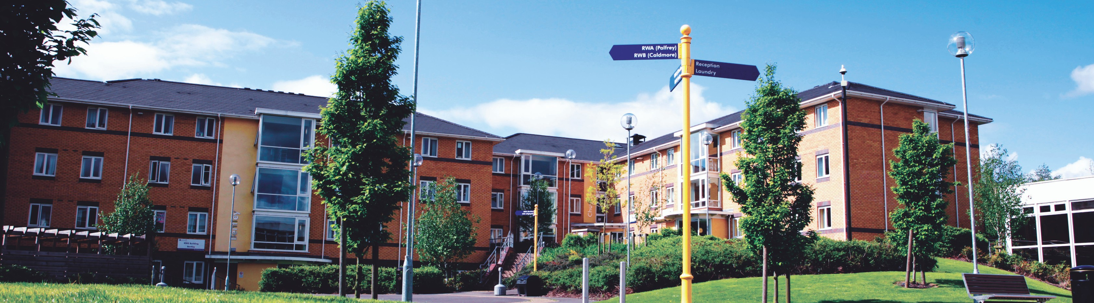Application Form
Good Landlord's Guide

9

Name of Organisation: | Date:
Address: | Post Code:
Reception Contact Number: | Web site address:
Site Manager Name: Site Manager Signature: | Email / Tel No:
Regional Manager Name:  Regional Manager signature: | Email / Tel No:
Please complete the rest of this form in as much detail as possible and provide all evidence of compliance at the point of application.
1.Why do you want to join the scheme?
2.What can your organisation offer to the scheme and the students

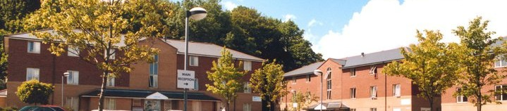Application Form
Good Landlord's Guide

10

Please ensure you complete all requirements below as these will form part of the verification assessment.
Applications will not be considered where any “Essential” categories cannot be met
Compliance and Governance
Criteria | Essential | Desirable
I am a member of the ANUK National Code
I will supply a copy of the last report relating to the scheme address stated above in the application form details
I will provide a copy of the report submitted to the ANUK National Code with regards to the number of complaints recorded with the code within the last 12 months.
I will sign up to a Data Sharing Agreement and abide by all the terms and conditions stated within this
I will submit all of the Risk Assessment or other compliance documentation to outline the safety of the premises to ensure the students safety
A business continuity plan is in operation for the premises and will be provided
Pastoral Support / Health and Well | being
The following processes and policies are required to be document and clearly evident on your web sites.
Please provide copies of the documents and the hyperlinks.
We have a student conduct policy (anti-social behaviour, breaches of tenancy)
Do you have a rent arrears / debt procedures?
Do you issue Notice to Quit or evict students – if yes do you have policies and processes to evidence?
Do you have an on-site staff / security provision 24 hours a day?
Do you have a Complaints process and is there an escalation process?
Do you have any staff on site with experience who can assist students with mental health, depression and anxiety?

University of Wolverhampton Camp Street
Wolverhampton WV1 1AD
Tel: +44 1902 321 000
wlv.ac.uk/university-life/accommodation/

