Your University at your side

Counsellors at the University of Wolverhampton:
Confidence and self-esteem
- provide free and confidential individual counselling
- offer non-judgemental support and understanding
- are professionally trained
- are experienced in dealing with a wide range of problems

Counselling can:
- help you to develop your strengths
- offer you the chance to focus on and understand your difficulties
- enable you to make positive decisions and changes
- help you to develop the skills and resources to cope
- help prevent small problems from becoming bigger.

Get in touch
You can make an appointment to see a counsellor by filling out the Contact Us form at www.wlv.ac.uk/SSW, alternatively, you can come along to one of our drop-in services. For more information go to the web address above and click on the Mental Health and Wellbeing option. From here you will find a wealth of useful information and self-help tools as well as our Drop-ins and Group activities.

Confidence and self-esteem
Some tips to help you feel better about yourself

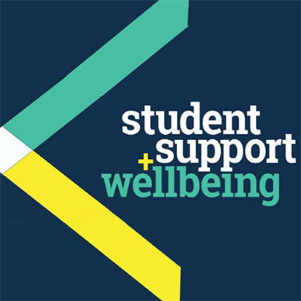

University Counselling Service

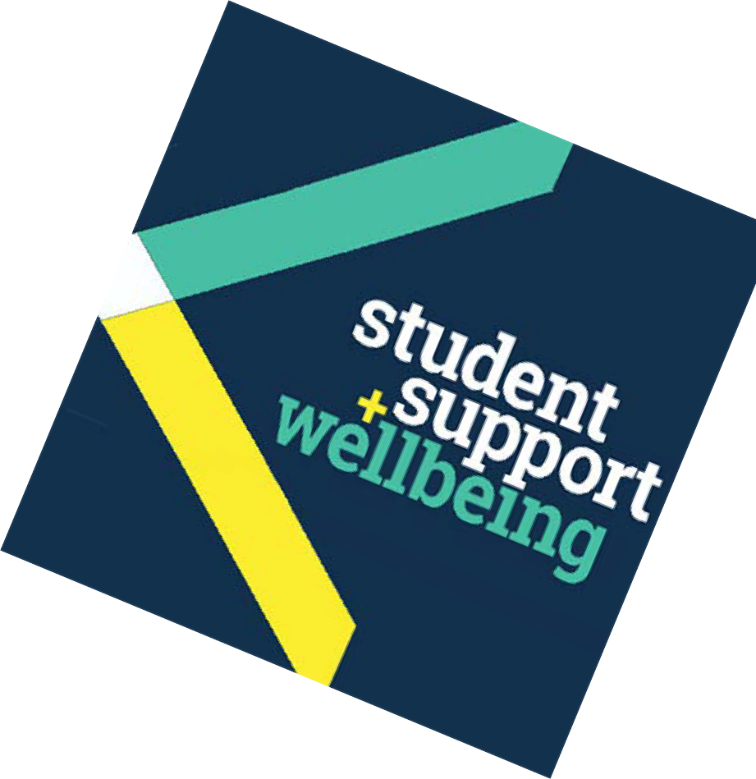Introduction
Confidence is largely determined by our opinion of ourselves. We feel confident when we can completely accept who we are (whenever and however). So why is it so difficult to value and appreciate ourselves at times?
Most of us can recall someones’ negative opinion of us. We may have digested these messages and incorporated them into how we currently think about ourselves.

“Someones’ opinion of you does not have to become your reality.” (Les Brown)*
*Les Brown, motivational speaker and autho.r

www.quotationsbook.com/quote/28525

Remember, everybody lacks confidence at times. Even confident-looking people can, and do, feel unsure of themselves.
Life events can boost or knock self-esteem. For instance, consider how pleased and proud you felt when you produced a good piece of work or got a (new) job.
Conversely, experiences of loss or rejection, such as the ending of a relationship, may have led to more negative thoughts and feelings.

To increase self-esteem and confidence: Take care of your physical health
Value yourself by making sure that you eat well, have sufficient relaxation time (eg. enjoy a soothing bath, listen to uplifting music) and get enough sleep.

Enjoy regular physical activity
Regular physical activity can benefit your physical, emotional and mental health, thereby positively influencing your sense of well-being.
20 minutes a day spent swimming, cycling, running, dancing, playing sports, training at a gym or walking briskly can cause the brain to release chemicals called endorphins, the bodys’ natural painkillers, which can help you to feel good.

Seek positive experiences
Plan some fun things in your week. Do something that you enjoy such as going on a night out, eating a favourite food or watching a favourite DVD. Take the time to look after yourself by having some pampering time or exercising.
Try finding out more about yourself: perhaps start by practising a few mindfulness techniques.

Recognise your positive features
Identify your qualities (who you are eg. honest, caring, determined) and your abilities (what you do). Start with the experience of being a student or the role you have at work: you must already be good at several things and possess a number of skills to have come this fa.r
Don’t forget to learn how to take a compliment!

Celebrate your successes
Remember all the good things you have achieved, such as doing a good piece of work, or mastering a new skill, like driving.

Smile. It’s good for you!
Science has shown that smiling relieves stress, boosts immune function and lowers blood pressure. Furthermore, studies have shown that smiling or laughing widely (enough to make the corners of your eyes wrinkle) causes the brain to release chemicals which can make you feel good (endorphins) and help you to relax (serotonin).

Take the focus off yourself
In other words, become less self-conscious. Do something you enjoy that will hold your attention, such as painting, cooking or swimming. Reach out to other people. Why not start with a smile? Smiling is contagious. Try it and see how many people smile back at you! Do something for someone else.

“I have become more confident within myself,and hence, have developed a more positive attitude”

You might like to read:
Lindenfield, G. (2000)Self Esteem. London: Harper Collins
Lawrence Preston, D. (2005)365 Steps to Self-Confidence.
Oxford: How To Books
Other leaflets in this series:Becoming Assertive

People you might want to contact:
- Family/ friends
- Your doctor

Other useful websites:
The Royal College of Psychiatrists
www.rcpsych.ac.uk/healthadvice/atozindex.aspx
Advice from Mind:
www.mind.org.uk/information-support/mental-health-a-z/
Useful leaflets:
www.ntw.nhs.uk/pic/selfhelp/
Health A-Z at:
www.nhs.uk
Free meditation exercises: http://franticworld.com/free-meditations- from-mindfulness/

