Printing Documents

Home Screen:
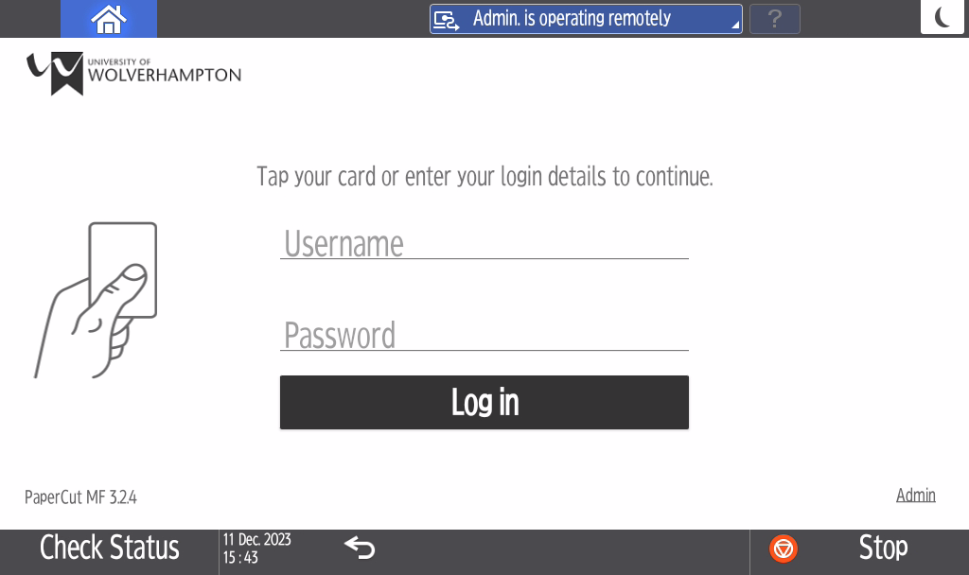

Tap your ID card or enter your university email address and password

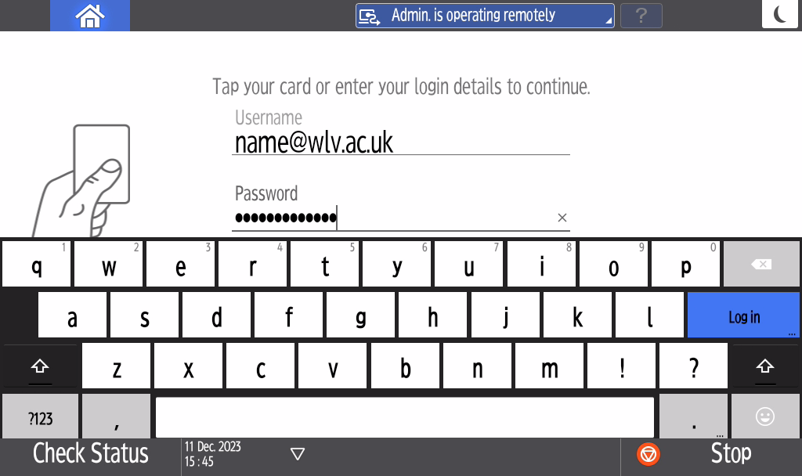
Select ‘Print release’ to print 1 or more documents selectively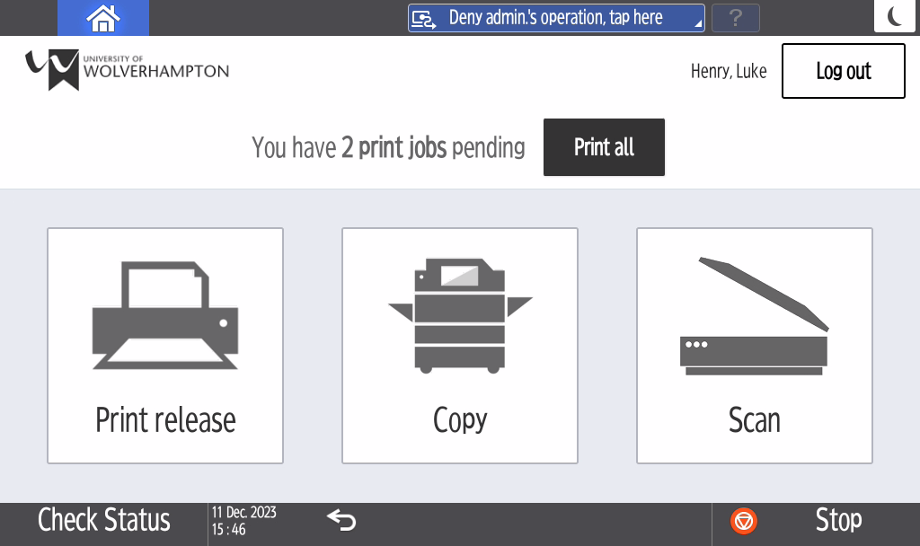

Choose the document(s) you would like to print and press ‘Print’
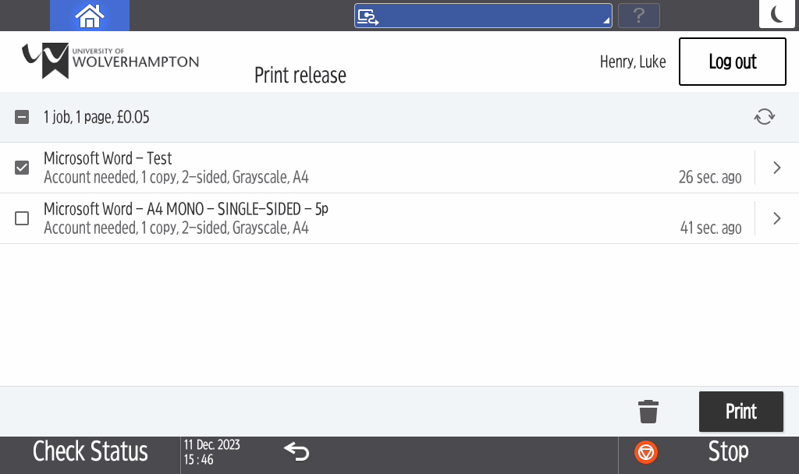

Select your work order below (If you have multiple please select the most appropriate)
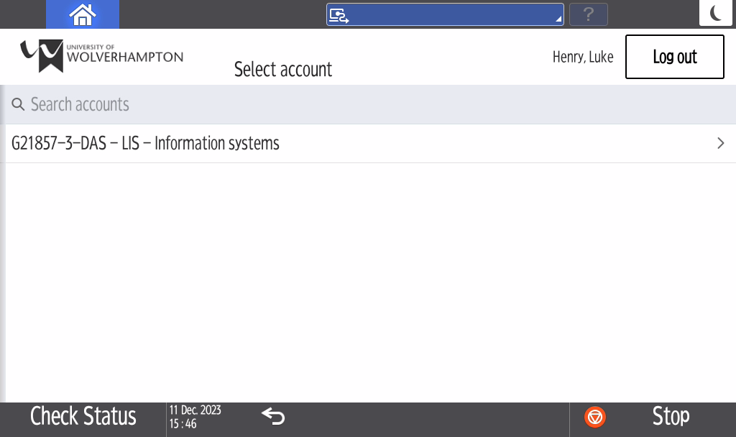

To Print all documents Select ‘Print all’ which will print all queued documents
