

**University of Wolverhampton Harvard Style Referencing**

**Full Guide**

**July 2017**

**Skills for Learning**

## www.wlv.ac.uk/skills

## Harvard Referencing

Referencing is the method used to ensure that other research influences are recognised within your assignment. Referencing includes two main parts:

* a citation within the text of your assignment
* a list of references at the end of your assignment

## Why do I need to reference?

Correct referencing helps ensure that you avoid being accused of plagiarism. Most assignments during your time at the University of Wolverhampton will be assessed on the quality of your referencing which will count towards your grade. Referencing also ensures that you can demonstrate how your ideas build upon the research of others. If someone is reading your assignment, they should be able to use your referencing to find the sources you have used to help with your assignment. This is also useful when you read published sources - if you find an interesting source then the items on its reference list may be interesting too.

The University of Wolverhampton mainly supports the Harvard referencing system, but other systems do exist. Check with your Faculty for the one they recommend. Whichever style you use, it is important to be clear, consistent and correct, making sure you include all the relevant details.

**Please note:** this is standard guidance only – if your lecturer has different requirements, please follow their instructions.

**Checklist of what to include for the most common information sources:**



[Type a quote from the document or the summary of an interesting point. You can position the text box anywhere in the document. Use the Drawing Tools tab to change the formatting of the pull quote text box.]

Pears, R. and Shields, G. (2010) *Cite them right: The essential referencing guide*. 8th ed. Basingstoke: Palgrave Macmillan.

## Contents

|  |  |
| --- | --- |
| Referencing in your text | 4 |
| Author rules | 5 |
| References deconstructed - Books | 7 |
| Books | 8 |
| Edited Books | 9 |
| References deconstructed - Journal Articles | 10 |
| Journal Articles | 11 |
| Newspaper Articles | 12 |
| Theses | 12 |
| Conferences | 13 |
| Reports | 14 |
| Market Research Reports | 14 |
| British Standards | 15 |
| Maps | 15 |
| Images | 16 |
| References deconstructed - Web Pages | 17 |
| Web Pages | 17 |
| Blogs | 18 |
| Canvas | 18 |
| YouTube & Online videos | 18 |
| Podcasts | 19 |
| DVD & Blu Ray | 19 |
| Television | 19 |
| Advertisements | 20 |
| Personal Communications | 20 |
| Subject Specific Examples | 21 |
| Interactive Guide | 21 |
| Examples for Harvard Style Law | 22 |
| Examples for Health students | 23 |
| Examples for Education students | 25 |
| Examples for Business students | 26 |
| Examples for Science students | 27 |
| Examples for Technology students | 28 |
| Examples for Art & Design students | 29 |
| Examples for Performing Arts students | 30 |
| Example A-Z Reference List | 31 |

## Referencing in your text

When you summarise, refer to, or quote from an author's work in your document, you need to acknowledge your source in the text. This is called an ‘in-text citation’. When using Harvard, you do this by putting the author’s name, and publication year. If the name of the author appears naturally in your sentence, only the year should be in brackets. If you use a direct quote the page number should also be included.

**Examples**:

Excellent study skills are fundamental to academic success (Cottrell, 2010)

or

Cottrell (2010) argues that excellent study skills are fundamental to academic success.

or

“The importance of academic skills should not be underestimated” (Cottrell, 2010, p.19)

In the reference list, you then put the full details of the reference to enable a reader to trace the source of the information that you have used:

Example: Cottrell, S. (2010) *Academic skills.* 2nd ed. London: Spon Press.

**Long quotations**

For long quotations of more than 4 lines, you should indent the quotation and there is no requirement for quotation marks.

### In-text citation

Depending on how many authors there are for your source, the in-text citation would be as follows;

|  |  |  |
| --- | --- | --- |
| One Author | (Smith, 2015) | …Smith (2015) argues that…. |
| Two Authors | (Smith and Jones, 2015) | …according to Smith and Jones (2015)…. |
| Three Authors | (Smith, Jones and Brown, 2015) | ….research by Smith, Jones and Brown (2015) showed that…. |
| More than three Authors | (Smith *et al.*, 2015) | Smith *et al.* (2015) proved that…. |

In the reference list, all authors should be listed as shown below with surname/family name followed by the initial(s) of any given names.

Smith, E.J., Jones, E.S. and Brown, R.C. (2015) *Molecular neuropharmacology: a foundation for clinical neuroscience*. New York: McGraw-Hill.

## Author rules

**Organisation as author**

If there is only an organisation’s name on an item and no named individuals, use the organisation as the author.

Example: University of Wolverhampton (2014)…

**Note**: some organisations are also known by an abbreviation, for example the Royal College of Nursing (RCN). Give the full name the first time you use the organisation in your text and then use the abbreviation for the citation and any later mentions.

Example: Information from the Royal College of Nursing (RCN, 2016) suggests…

**Author has published 2 or more items in the same year**

If two or more documents are by the exact same author(s) in the same year, add lower-case letters after the year (a, b, c, etc.) to distinguish between them in your text and in your reference list. The first of the sources you mention in your essay would be a, the next b and so on.

Example:

Morris (1999a) concludes that…additionally Morris (1999b) states….

**Multiple sources for same idea**

You can group together sources that talk about the same point by listing them within the same in-text citation. Use semi-colons ; to separate each item. List by year with oldest first.

Example: A number of reports (Smith, 2008; Jones, 2009; Brown, 2011; Williams *et al*., 2013; Thomas and Lewis, 2014) revealed that….

**Secondary referencing (authors quoting other authors)**

Sometimes you may want to reference an author who is quoting another information source that you haven’t seen. You should try to find the original source, but if that is not possible, you need to make it clear that you have not seen the original source yourself.

Within your text, you cite the original author, followed by the author of the secondary source.

Examples:

“It will not require violence to succeed, and it cannot be successfully resisted by violence” (Reich, 1971, in Singer, 1997, p.90).

Reich (1971, in Singer, 1997, p.90) stated that “it will not require violence to succeed, and it cannot be successfully resisted by violence”.

In your reference list at the end, you list the book you actually saw:

Singer, P. (1997) *How are we to live?* Oxford: Oxford University Press.

**Author/date missing**

Ideally you should only reference sources where the author and date information is clearly available but there may be times where this information is missing. In such instances, make sure that the source would still be considered reliable enough to use in an academic assignment.

If there isn’t an author (named individuals or organisation) given, use the title (in italics) for your citation and at the start of your main reference. For example;

(*Oxford English Dictionary*, 1989)

*Oxford English Dictionary* (1989) 2nd ed. Oxford: Clarendon Press.

If no date of publication can be identified, use (no date) for the citation and in your main reference.

Example:

(University Hospitals Birmingham NHS Trust, no date)

University Hospitals Birmingham NHS Trust (no date) *Privacy and dignity* [online]. [Accessed 12 April 2017]. Available at: <www.uhb.nhs.uk/privacy-and-dignity.htm>.

**Reference list entries**

Each citation in your text leads the reader to the full information about the item in your reference list.

Each item in your reference list should only appear once, regardless of how many in-text citations you have for that item.

Your list should be completed in alphabetical order by author's surname regardless of the format of the information source. See page 31 for an example of a completed reference list.

**Reference list or bibliography?**

A reference list is a list of all the information sources that you have cited in your text. A bibliography is a list of items that you have read, and that have informed your thinking, but not specifically cited in your assignment. Check the requirements for each module with your tutor.

**PDFs.**

Many online documents are in a pdf format. They should not be referenced as a pdf but according to their document type e.g. a journal or book.

## References deconstructed: Books

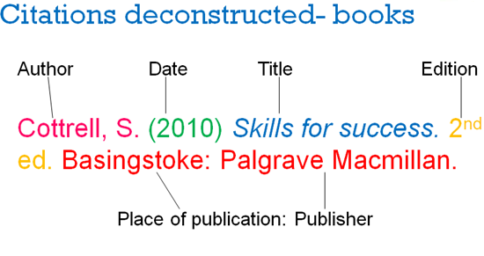

*in italics*

All of the information for your reference can be found on the copyright page of the book (normally 2 or 3 pages into the book). The place of publication is the town or city rather than the county or country. If there are multiple publication places give the most local, with a UK town over an international one; if only international locations are listed, use the first place mentioned. If it is a town in the USA – list the town and the state initials, e.g. Hoboken, NJ.

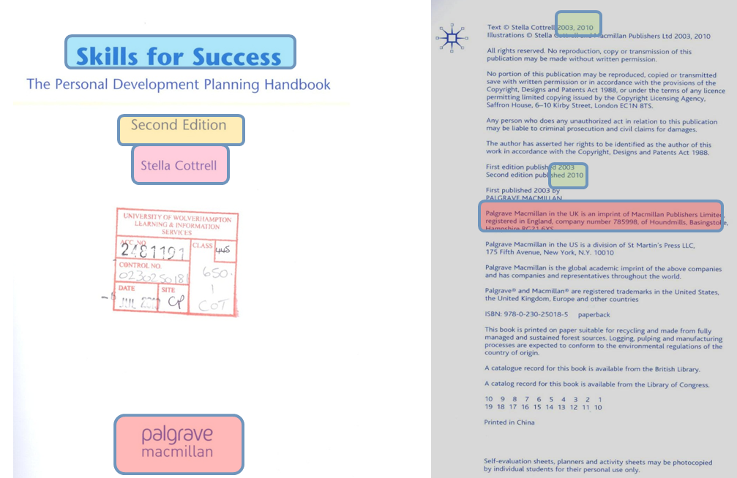

## Books

**Book with one author**

Include the following information:

Author (Published Year) *Title of book*. Edition (if later than 1st). Place of Publication: Publisher.

Example:

Storey, N. (2013) *Electronics: A systems approach*. 5th ed. Harlow: Pearson.

**Note:** Only state the edition if it is a second edition or later.

**Book with two or three authors**

Include the following information:

Authors (Published Year) *Title of book*. Edition (if later than 1st). Place of Publication: Publisher.

Example:

Field, P., Jasper, C. and Littler, L. (2014) *Practice education in social work: Achieving professional standards.* Northwich: Critical Publishing.

**Book with more than three authors**

Include the following information:  
Authors (Published Year) *Title of book*. Edition (if later than 1st). Place of Publication: Publisher.

Example:

Epstein, O., Perkin, G.D., Cookson, J., Watt, I.S., Rakhit, R., Robinson, A.W. and Hornett, G.A.W. (2008) *Clinical examination*. 4th ed. Oxford: Mosby Elsevier.

**Electronic Book (e-book)**

Include the following information:

Author(s) (Published Year) *Title of book* [online]. Edition (if later than 1st). Place of Publication: Publisher. [Accessed date]. Available at: <web address>.

**Example: dawsonera database e-book**

Farrell, M. (2010) *Debating special education* [online]. London: Routledge. [Accessed 24 August 2015]. Available at: <www.dawsonera.com>.

**Example: Google book**

Miller, A.I. (2001) *Einstein, Picasso: Space, time and the beauty that causes havoc* [online]. New York: Basic Books. [Accessed 24 August 2015]. Available at: <https://books.google.co.uk/books?id=VEPaSUitrDkC&printsec=frontcover&dq=picasso&hl=en&sa=X&ved=0CF4Q6AEwCWoVChMIg_LixPzBxwIVxr4UCh21OQYA#v=onepage&q=picasso&f=false>.

**Note:** If accessing an e-book via a library database such as Dawsonera, Myilibrary, Knovel, Ebsco or Safari you can use the short URL for the main website. If it has been accessed via Google books or an external web site, then the full URL must be included.

**Translated book**

Include the following information:

Author(s) (Year of translated publication) *Title of book*. Translated by name(s) of translator(s) with initial(s) before surname(s). Place of Publication: Publisher.

Example:

Delibes, M. (2013) *The path*. Translated by G. Haycraft and R. Haycraft. London: Dolphin Books.

## Edited books

## Edited books contain collections of chapters which are written by different authors and collated by an editor or editors.

**Edited Book**

Include the following information:

Editor(s) (ed.) or (eds.) (Published Year) *Title of book.* Edition (if later than 1st). Place of publication: Publisher.

Example:

Fry, H., Ketteridge, S. and Marshall, S. (eds.) (2015) *A handbook for teaching and learning in higher education.* 4th ed. Abingdon: Routledge.

**Chapter within an edited book**

Include the following information:

Chapter author(s) (Published Year) Chapter title. *in*Editor(s) of book  (ed.) or (eds.) *Title of book.*Edition (if later than 1st). Place of Publication: Publisher, Page numbers of whole chapter.

Example:

Butcher, C. (2015) Describing what students should learn. *in* Fry, H., Ketteridge, S. and Marshall, S. (eds.) *A handbook for teaching and learning in higher education.* 4th ed. Abingdon: Routledge, pp.80-93.

**Note:** use (ed.) for a single editor and (eds.) where there are two or more editors.

**Chapter within an online edited book**

Include the following information:

Chapter author(s) (Published Year) Chapter title. *in*Editor(s) of book  (ed.) or (eds.) *Title of book* [online]*.*Edition (if later than 1st). Place of Publication: Publisher, Page numbers of whole chapter. [Accessed date]. Available at: <web address>.

Example:

Butcher, C. (2015) Describing what students should learn. *in* Fry, H., Ketteridge, S. and Marshall, S. (eds.) *A handbook for teaching and learning in higher education* [online]*.* 4th ed. Abingdon: Routledge, pp.80-93. [Accessed 19 May 2017]. Available at: <www.dawsonera.com>.

## References deconstructed: Journal Articles

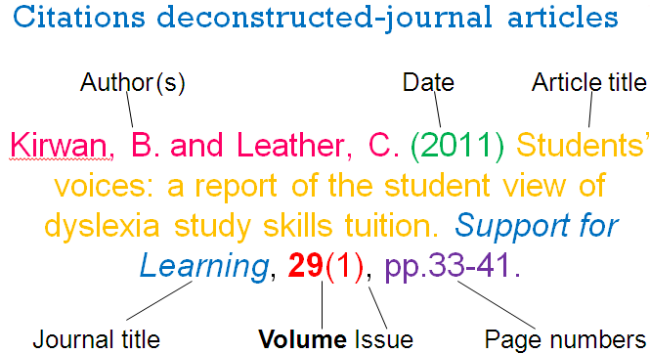

**in bold**

*in italics*

All the information for your reference can normally be found on the first page of the journal article:

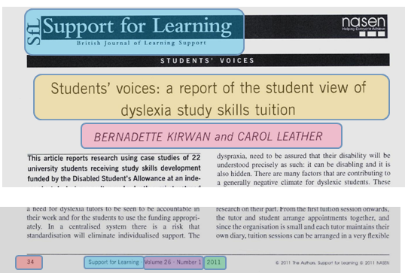

## Journal Articles

**Journal article**

Include the following information:  
Author(s) (Published Year) Title of Article. *Title of Journal*, **Volume number**(issue number), Page numbers of whole article.

Example:

Humberstones, B. and Stana, I. (2011) Outdoor learning. *Education 3-13: International Journal of Primary, Elementary and Early Years Education*, **39**(5), pp.529-540.

**Note:** Some journals may not have either a volume or issue number, in which case leave the missing number out of your reference. Where both the volume and issue are not stated, give additional date information instead - include the full date where available or the month(s) or season, e.g. 26 June or June/July or Summer.

**Electronic journal article**

Include the following information:

Author(s) (Published Year) Title of Article. *Title of Journal* [online]. **Volume number** (issue number), Page numbers of whole article. [Accessed date]. Available at: <web address>.

Example:

Humberstones, B. and Stana, I. (2011) Outdoor learning. *Education 3-13: International Journal of Primary, Elementary and Early Years Education* [online]. **39**(5), pp.529-540. [Accessed 24 August 2015]. Available at: <http://www.tandfonline.com>.

**Note:** If accessing the journal article online via a library database such as ProQuest or Ebsco, you can use the short URL for the main website. However, if accessing the article through a general internet search the full URL must be included.

**Preprints:** Sometimes articles are made available online prior to print publication and may not have full referencing details assigned. Include the volume, issue and/or page numbers in your reference where available, but any missing details can be replaced by the word Preprint as shown in the example below;

Strandroos, L. and Antelius, E. (2016) Interaction and common ground in dementia: Communication across linguistic and cultural diversity in a residential dementia care setting. *Health* [online]. Preprint, pp.1-17. [Accessed 6 February 2017]. Available at: <http://journals.sagepub.com/doi/pdf/10.1177/1363459316677626>.

## Newspaper Articles

**Printed newspaper articles**

Include the following information:

Author(s) (Published Year) Title of article. *Newspaper name.* Day and month published, page number(s).

Example:

Allen, K. (2014) Barratt moves to tailor house designs and locations to older population. *Financial Times.* 4 November, p.1.

**Online newspaper articles**

Include the following information:

Author(s) (Published Year) Title of Article. *Newspaper name* [online]. Day and month published, page number(s) if available. [Accessed date]. Available at: <web address>.

Example:

Granger, K. (2015) I want my legacy to be that the NHS treats all patients with compassion. *The Guardian* [online]. 2 February. [Accessed 19 March 2015].

Available at: <http://www.theguardian.com/healthcare-network/2014/may/21/friendly-introduction-transform-patient-experience>.

**Note:** Some newspaper articles may not have an author, in these cases name the newspaper in place of an author. If accessing the article online via a library database such as ProQuest Newspapers (UK Newsstand), you can use the short URL for the main website. However, if the article is from an online newspaper website then the full URL must be included.

## Theses

**Thesis**

Include the following information:  
Author (Year) *Title of thesis*. Qualification, Awarding Institution.

Example:

Saxton, J. M. (1994) *Exercise-induced damage to human skeletal muscle*. Ph.D. Thesis, University of Wolverhampton.

**Online thesis**

Include the following information:  
Author (Year) *Title of thesis* [online]. Qualification, Awarding Institution. [Accessed date]. Available at: <web address>.

Example:

Ismail, A. (2014) *Seawater as a hydraulic fluid: Corrosion mechanisms and rates of engineering materials* [online]. Ph.D. Thesis, University of Leeds. [Accessed 1 September 2015]. Available at: <http://ethos.bl.uk>.

## Conferences

**Full conference proceedings**

Include the following information:

Organisation holding conference (Published Year) *Title of conference: plus any additional information*. Venue and place held, Dates. Place of Publication: Publisher.

Example:

Institute for Small Business Affairs (2002) *Small firms: the 25th ISBA small firms conference*. Robert Gordon University, Aberdeen, 15-17 November. Leeds: Institute for Small Business Affairs.

**Individual conference paper**

Include the following information:

Author(s) (Published Year) Title of paper. *Title of conference: plus any additional information*. Venue and place held, Dates. Place of Publication: Publisher, Page numbers - first page and last page.

Example:

Lloyd, S. (2002) Capturing the consumer. *Small firms: the 25th ISBA small firms conference.* Robert Gordon University, Aberdeen, 15-17 November. Leeds: Institute for Small Business Affairs, pp.132-138.

**Online full conference proceedings**

Include the following information:

Organisation holding conference (Published Year) *Title of conference: plus any additional information* [online]. Venue and place held, Dates. [Accessed date]. Available at: <web address>.

Example:

IEEE Computer Society (2009) *Cover Art: 14th IEEE International Conference on Engineering of Complex Computer Systems* [online].University of Potsdam, Potsdam, 2-4 June. [Accessed 14 June 2009]. Available at: <http://www.computer.org/portal/web/csdl/doi/10.1109/ICECCS.2009.57>.

**Online conference paper**

Include the following information:

Author(s) (Published Year) Title of paper. *Title of conference: plus any additional information* [online]. Venue and place held, Dates, Page numbers if available. [Accessed date]. Available at: <web address>.

Example:

Pellizzoni, R., Sha, L. and Bradford. R.M. (2009) ASIIST: I/O Tool for Architecture Designs. *Cover Art: 14th IEEE Conference on Engineering of Complex Computer Systems* [online].University of Potsdam, Potsdam, 2-4 June. [Accessed 14 June 2009]. Available at: <http://www.computer.org/portalcsdl/doi/10.1109/ICECCS.2009.57>.

## 

## Reports

**Report accessed online**

Include the following information:

Author (Published Year) *Title of report* [online]. Reference number (if there is one). [Accessed date]. Available at: <full web address>.

Example:

Department for Education (DfE) (2017) *Early education and childcare: Statutory guidance for local authorities* [online]. Ref: DFE-00083-2017. [Accessed 13 April 2017]. Available at: <https://www.gov.uk/government/uploads/system/uploads/attachment_data/file/596460/early_education_and_childcare_statutory_guidance_2017.pdf>.

**Printed report with named authors**

Include the following information:

Author(s) (Published Year) *Title of report*. Reference number (if there is one). Place of Publication: Publisher.

Example:

Hastings, A., Bailey, N., Besemer, K., Bramley, G., Gannon, M. and Watkins, D. (2013) *Coping with the cuts? Local government and poorer communities*. JRF Programme Paper Ref: 2967. York: Joseph Rowntree Foundation.

**Printed report with organisation as author**

Include the following information:

Organisation name (Published Year) *Title of report*. Reference number (if there is one). Place of Publication: Publisher.

Example:

Department for Education (DfE) (2017) *Early education and childcare: Statutory guidance for local authorities*. Ref: DFE-00083-2017. London: The Stationery Office.

**Government command, green or white paper**

Include the following information:

Department (Published Year) *Title of paper.* Cm. number. Place of Publication: Publisher.

Example:

Department for Work and Pensions (DWP) (2014) *Post-legislative scrutiny of the Pensions Act 2007.* Cm. 9001. London: The Stationery Office.

## Market Research Reports

**Market Research Reports**

Include the following information:

Author (Published Year) *Title of report*. Place of Publication: Publisher.

Example:

Mintel (2008) *Coffee: Mintel marketing report*. London: Mintel.

**Online Market Research Reports**

Include the following information:

Author (Published Year) *Title of report* [online]. [Accessed date]. Available at: <web address>.

Example:

Mintel (2008) *Coffee: Mintel marketing report* [online]. [Accessed 12 December 2008]. Available at: <http://academic.mintel.com>.

## British Standards

**British Standards**

Include the following information:

Author (Published Year) *Name and title of standard.* Place of Publication: Publisher.

Example:

British Standards Institution (2008) *BS EN 1173:2008:* *Copper and copper alloys - Material condition designation*. London: BSI.

**British Standards accessed online**

Include the following:

Author (Published Year) *Name and title of standard* [online]. [Accessed date]. Available at: <web address>.

Example:

British Standards Institution (2008) *BS 437:2008:* *Specifications for cast iron drain pipes, fittings and their joints for socketed and socketless systems* [online]. [Accessed 15 August 2008]. Available at: <http://www.bsol.bsigroup.com>.

## Maps

**Map**

Include the following information:

Author (Published Year) *Title of map*, sheet number, scale and series. Place of Publication: Publisher.

Example:

Ordnance Survey (2000) *Telford, Ironbridge and The Wrekin,* sheet 242, 1:25,000 Explorer Series. Southampton: Ordnance Survey.

**Online Map**

Include the following:

Author (Published Year) *Title of map section* [online]. [Accessed date]. Available at: <web address>.

Example:

Tele Atlas (2009) *Google Maps: Burslem* [online]. [Accessed 19 July 2009]. Available at: <http://maps.google.co.uk>.

**Note:** When you are referencing online maps make sure you note the author and not just the search engine, for example Tele Atlas produce Google Maps.

## Images

**Image in a book**

Include the following information:  
Author(s) (Published Year) *Title of book*. Edition (if later than 1st). Place of Publication: Publisher, page image is on.

Example:

Himka, J. (1988) *Galician villagers and the Ukrainian national movement in the nineteenth century*. Basingstoke: Macmillan, p.44.

**Image from a library database**

Include the following information:  
Author (Published Year) *Title of item.* Format of original work[online]. [Accessed date]. Available at: <web address>.

Example:

Dali, S. (1958) *Madonna.* Oil on canvas [online]. [Accessed 10 July 2009]. Available at: <http://www.oxfordartonline.com>.

**Image from a website**

Include the following information:  
Author / Artist / Username (Published Year) *Title of image.* Name of hosting website (if applicable)[online]. [Accessed date]. Available at: <web address>.

Example:

Robinthesky (2015) *Midtown 2052*. Instagram [online]. [Accessed 1 September 2015]. Available at: <https://instagram.com/p/7EPDbkl3E-/?taken-by=robinthesky>.

Example:

Eddie1gman (2015) *Gibbs reflective cycle* [online]. [Accessed 1 September 2015]. Available at: <https://eddie1gman.files.wordpress.com/2015/03/gibbs.png>.

**Note:** If the diagram, picture or graph has been created by someone other than the author of the source you have read, it should be referenced following the ‘Secondary referencing’ rules (see page 4). If you are referencing an image from a website make sure you reference the actual site and not the search engine used such as Google Images.

**Figures:** if you insert an image, graph, chart or diagram into your assignment it should be labelled with a caption directly underneath containing a figure number, title and the (author, date) source citation. For example;



Figure 1: University of Wolverhampton logo (University of Wolverhampton, 2017)

## References deconstructed: Web Pages

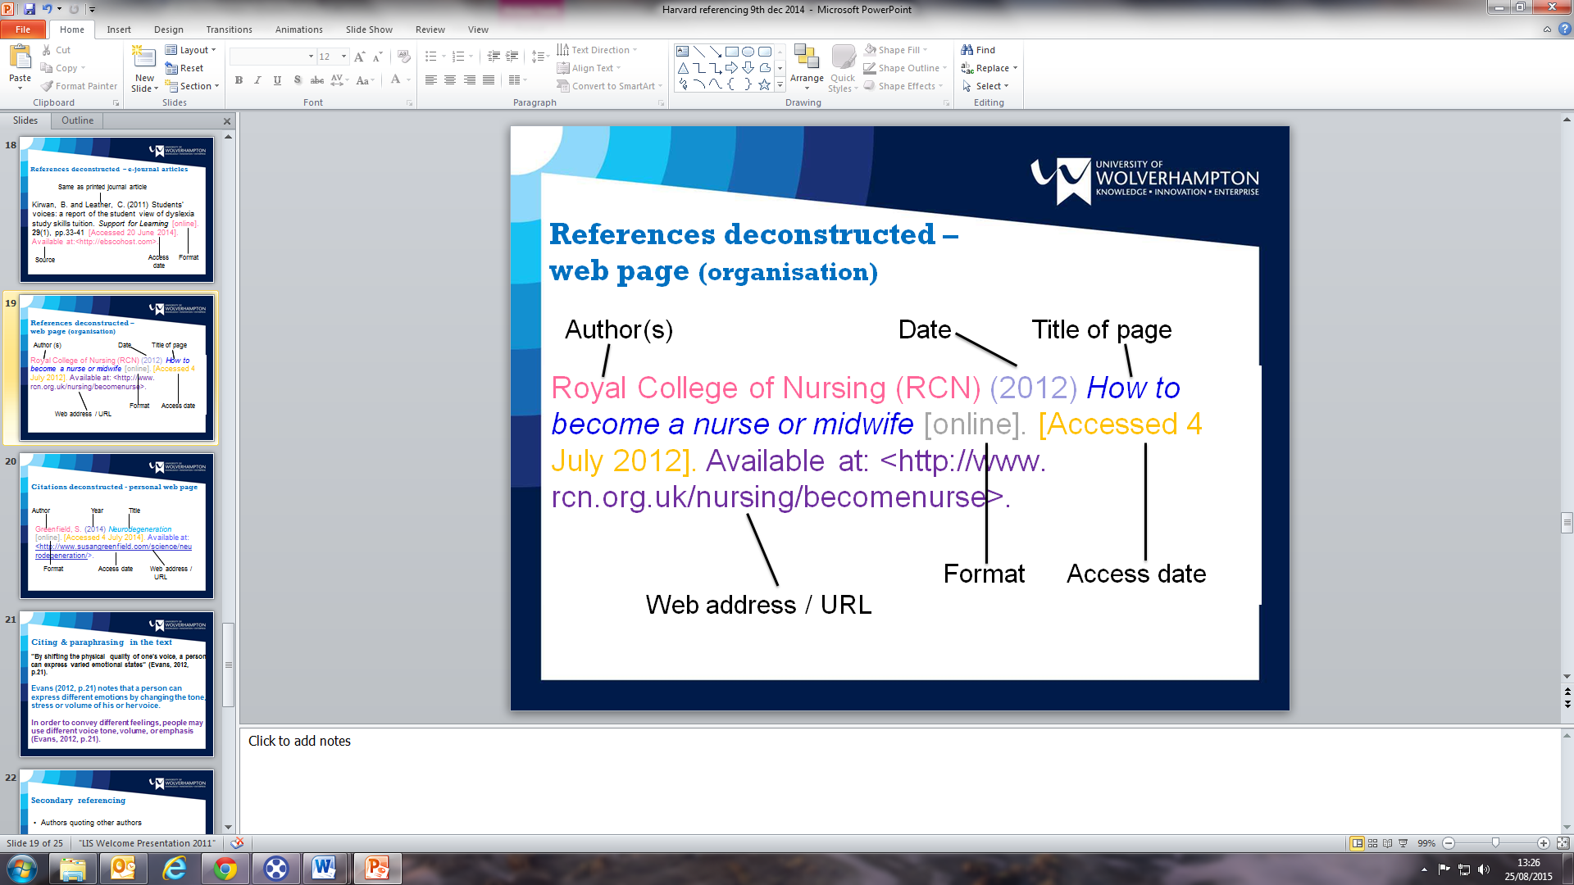

*in italics*

## Web pages

**Web page with organisation as author**

Include the following information:

Organisation name (Published Year) *Title of Webpage* [online]. [Accessed date]. Available at: < full web address>.

Example:

Smart Design (2015) *Oxo good grips: A startup that keeps on growing* [online]. [Accessed 4 March 2015]. Available at: <http://smartdesignworldwide.com/work/oxo-good-grips/>.

**Web page with named author(s)**

Include the following information:  
Author(s) (Published Year) *Title of Webpage*[online]. [Accessed date]. Available at: <full web address>.

Example:

LeBlanc, M. (2015) *Friedrich Frobel: His life and influence on education* [online]. [Accessed 28 August 2015]. Available at: <http://www.communityplaythings.co.uk/resources/articles/friedrich-froebel.html>.

**Note:** If the website has no author you should use the site’s URL. However, if a web page has no author you might question whether it is a suitable source to use in your academic work. If a website has no date, use the author and (no date); be sure that the information is suitable and not out of date though. A copyright date (where available) can be used if the information itself isn’t dated. Some websites may give a date range e.g. University of Wolverhampton, 1999-2005; in this instance always use the latest date given.

## Blogs

**Blogs**

Include the following information:  
Author or username (Published Year) *Title of blog post*[blog entry]. [Accessed date]. Available at: <web address>.

Example:

IB Psychology (2014) *Social identity theory (Tajfel 1970)* [blog entry]. [Accessed 25 August 2015]. Available at: <http://ib-psych.blogspot.co.uk/2014/02/social-identity-theory-tajfel-1970.html>.

## Canvas

**Note:** Not all lecturers are happy for you to cite directly from lectures or module support materials, so it is good practice to check this with your tutor. If the lecturer is drawing from a published source, you should find that source for use in your own work instead.

**Lecture notes or PowerPoint slides**

Include the following information:

Lecturer’s Name / Owner of Canvas Topic (Year) Details of item, e.g. title, lecture number. *Module code: Module title* [online]. [Accessed date]. Available at: <web address>.

Example:

Bernardes, J. (2016) Lecture 4: Problem of studying family living. *6CF008: Critical Debates in Social Policy* [online]. [Accessed 16 October 2016]. Available at: <http://canvas.wlv.ac.uk/>.

**Document on Canvas not written by lecturer:**

Include the following information:

Author (Published Year) Title of document – details of what it is. *Module code: Module title* [online]. [Accessed date]. Available at: <web address>.

Example:

Design Council (2009) Ian Macleod Distillers case study. *5EB001: Issues in Hospitality* [online]. [Accessed 25 May 2017]. Available at: <http://canvas.wlv.ac.uk/>.

## 

## YouTube & Online videos

**YouTube Videos**

Include the following information:

Author or Username (Uploaded Year) *Title of video* [online]. [Accessed date]. Available at: <web address>.

Example:

Rompkows (2007) *Half life in 60 seconds* [online]. [Accessed 1 September 2015]. Available at: <http://youtube.com*>.*

## Podcast

**Podcast**

Include the following information:  
Authors (Year uploaded) Title of podcast. *Details of series / podcast provider*. [online]. [Accessed date]. Available at: <web address>.

Example:

Johnson, B. (2009) Critical rethink in schools*. BBC schools podcast* [online]. [Accessed 7 January 2009]. Available at: <http://bbc/edu/podcasts.>.

## DVD & Blu Ray

**Film**

Include the following information:

*Title of film* (Year of distribution) Directed by name(s) of director(s) with initial(s) before surname(s) [Format]. Place of distribution: distribution company.

Example:

*Che, Part one* (2008) Directed by S. Soderbergh [DVD]. New York: IFC Films.

## Television

**Television Programme**

Include the following information:

*Title of programme* (Year of transmission) Name of Channel, Day and month of original broadcast.

Example:

*Little Britain* (2005) BBC Two Television, 23 June.

**Episode of a Television Series**

Title of episode (Year of transmission) *Title of programme,* Series and episode numbers, Name of Channel, Day and month of original broadcast.

Example:

Ink & Incapability (1987) *Blackadder,* Series 3 episode 2, BBC Two Television, 23 June.

**Episode of a Television Series viewed online**

Title of episode (Year of transmission) *Title of programme* [online],Series and episode numbers, Name of Channel, Day and month of original broadcast. [Accessed date]. Available at: <web address>.

Example:

Love You (2008) *Holby City* [online], Series 10 episode 4, BBC One Television, 9 June. [Accessed 15 June 2008]. Available at: <www.bbc.co.uk/iplayer>.

## Advertisements

**Advertisements**

Include the following information:

Advertiser (Year of transmission) *Title of advertisement* [Where seen] Date viewed.

Example: TV Advertisement

Vodafone (2009) *Advertisement for 3G mobile telephone* [advertisement on ITV Television]. Viewed 20 April 2009.

Example: Newspaper Advertisement

Vodafone (2009) *Advertisement for 3G mobile telephone* [advertisement in The Times]. Viewed 20 April 2009.

Example: Internet Advertisement

Vodafone (2009) *Advertisement for 3G mobile telephone* [online advertisement]. Viewed 20 April 2009. Available at: <http://www.sky.com>.

**Note:** include the Available at: <web address> for advertisements viewed online.

## Personal Communications

**Conversation or verbal presentation**

Include the following information:  
Name of presenter / participant (Year) *Subject of discussion* [type of communication]. Place (if applicable), Date of communication.

Example:

Telford and Wrekin Council (2015) *The bigger picture* [Internal meeting]. Telford, 24 April 2015.

**Email**

Include the following information:  
Name of message sender (Year) Email to (name of recipient with initial(s) then surname), date of message.

Example:

Stolarczuk, P. (2009) Email to J. Granger, 20 June 2009.

**Interview**

Include the following information:  
Person being interviewed (Year) Interviewed by name of interviewer (initial(s) before surname) for *TV programme or publication name* [medium of transmission]. Broadcast channel or publication name, date.

Example:

Blair, A. (2003) Interviewed by J. Paxman for *Newsnight* [Television interview].BBC Two Television, 2 February 2003.

**Note:** If you are referencing an interview remember to include the publication or broadcast (e.g. The Times or BBC One Television).

## Subject specific examples

|  |  |
| --- | --- |
| Harvard style Law | 22 |
| Examples for Health students | 23 |
| Examples for Education students | 25 |
| Examples for Business students | 26 |
| Examples for Science students | 27 |
| Examples for Technology students | 28 |
| Examples for Art & Design students | 29 |
| Examples for Performing Arts students | 30 |

## Interactive guide

Why not try our interactive [Harvard guide](http://www2.wlv.ac.uk/lib/help/demo/Interactive%20Harvard_skin.swf) (http://tinyurl.com/pyhdlgf ) and our [Plagiarism guide](http://www2.wlv.ac.uk/lib/help/demo/Plag.swf) (http://tinyurl.com/qc5othr )

[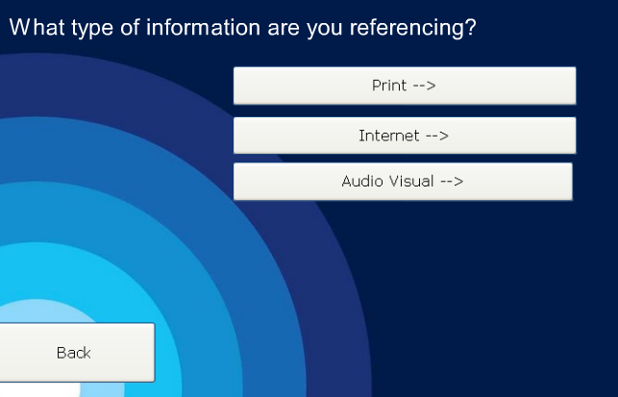](http://www2.wlv.ac.uk/lib/help/demo/Interactive%20Harvard_skin.swf)

**Need further help?**

If you need help with the Harvard referencing system, please do not hesitate to ask the Librarians within your local Learning Centre for assistance. You can also chat live online to a librarian using our 24/7 Assist service <http://www.wlv.ac.uk/lib/assist>.

## Harvard style law

These are examples of the Harvard referencing system, Law students using the Oxford style can refer to the full guide [here](https://www.wlv.ac.uk/lib/skills-for-learning/referencing/)

**UK Statute or Acts of Parliament**

Include the following information:

Great Britain Parliament (Published Year) *Title of act and year* [Act of Parliament]. London: HMSO.

Example:

Great Britain Parliament (2015) *Consumer Rights Act 2015* [Act of Parliament]. London: HMSO.

**Note:** The in-text citation for an Act of Parliament should give Great Britain Parliament as the author, e.g. (Great Britain Parliament, 2015). You should also mention the name of the Act within the general flow of your writing, for example;

According to the Mental Capacity Act 2005 (Great Britain Parliament, 2005) the…

**Law Reports (Case Law)**

Include the following information:

Name of case (Year) *Title of law report*, **Volume number**, page numbers of whole case.

Example:

Soars v Brotherton (2015) *All England Law Reports*, **1**, pp. 207-208.

**Note:** An Act of Parliament or Law Report should be referenced as a print source as shown in the examples above, even if the information was accessed online.

## Examples for Health students

**British National Formulary**

**Print copy:**

BMJ Group and the Royal Pharmaceutical Society (2011) *British National Formulary 61.* London: BMJ/Pharmaceutical Press.

**Note**: Always use the latest version of the British National Formulary which is available [online](https://oa-idp.wlv.ac.uk/oala/sso?target=https%3A%2F%2Fservice.medicinescomplete.com%2Fukfed%2Fdefault.aspx%3Furi%3Dhttps%3A%2F%2Fwww.medicinescomplete.com%2Fmc%2Fbnf%2Fcurrent%2F&shire=https%3A%2F%2Fservice.medicinescomplete.com%2Fukfed%2Foa%2Fauth%2Frcv%2Fshib%2Fpost&providerId=https%3A%2F%2Fwww.medicinescomplete.com%2Fmc%2Fshibboleth) to University of Wolverhampton staff and students.

**Online:**

BMJ Group and the Royal Pharmaceutical Society (2017) *British National Formulary May 2017* [online]. [Accessed 20 May 2017]. Available at: <https://www.medicinescomplete.com/mc/bnf/current/>.

**Cochrane Library Systematic Review**  
Include the following information:  
Author(s) (Year) Review title. *Cochrane Database of Systematic Reviews* [online]. (Issue number), Article number, pages. [Accessed date]. Available at: <web address>.

Example:  
Alfirevic. Z., Devane, D., Gyte, G.M.L. and Cuthbert, A. (2017) Continuous cardiotocography (CTG) as a form of electronic fetal monitoring (EFM) for fetal assessment during labour. *Cochrane Database of Systematic Reviews* [online]. (3), Art. No: CD006066, pp.1-137. [Accessed 15 May 2017]. Available at: <http://onlinelibrary.wiley.com/doi/10.1002/14651858.CD006066.pub3/epdf>.

**Command, White or Green Papers**

Department of Health (DH) (2015) *Culture change in the NHS: Applying the lessons of the Francis Inquiries*. Cm. 9009. London: The Stationery Office.

**Department of Health Report**

Department of Health (DH) (2016) *Community pharmacy in 2016/17 and beyond: Final package* [online]. [Accessed 13 April 2017]. Available at: <https://www.gov.uk/government/uploads/system/uploads/attachment_data/file/561495/Community_pharmacy_package_A.pdf>.

**Francis Report (Public Inquiry referenced as an online report)**

Francis, R. (2013) *Report of the Mid Staffordshire NHS Foundation Trust public inquiry* [online]. HC 898. [Accessed 4 April 2016]. Available at: <https://www.gov.uk/government/publications/report-of-the-mid-staffordshire-nhs-foundation-trust-public-inquiry>.

**NMC Code**

**Print copy:**

Nursing and Midwifery Council (2015) *The code: Professional standards of practice and behaviour for nurses and midwives.* London: Nursing and Midwifery Council.

**Online:**

Nursing and Midwifery Council (2015) *The code: Professional standards of practice and behaviour for nurses and midwives* [online]. [Accessed 20 May 2016]. Available at: <https://www.nmc.org.uk/globalassets/sitedocuments/nmc-publications/nmc-code.pdf>.

**NHS Report**

National Health Service (2003) *Can walking make you slimmer and healthier?* London: National Health Service.

**Policy document**

Include the following information:

Author (Year) *Title of document* [policy document]. Place of publication: Publisher.

Example:

Herefordshire Primary Care Trust (2010) *Oral Care* [policy document]. Hereford: Herefordshire Primary Care Trust.

**Confidential policy document**

Include the following information:

Host Organisation (Year) *Title of document* [policy document]. Host Organisation.

Example:

Host Organisation (2010) *Pharmacy dispensing procedures* [policy document]. Host Organisation.

**UK statutes or Acts of Parliament**

Great Britain Parliament (2010) *Child Poverty Act 2010* [Act of Parliament]. London: HMSO.

**Note:** see page 21 for Harvard-style Law in more detail.

## Examples for Education students

**Ofsted Report**

Office for Standards in Education (Ofsted) (2009) *Gifted and talented pupils in schools*. Ref: HMI 090132. London: Ofsted publications.

**National Curriculum Document**

Department for Education (DfE) (2013) *The National Curriculum in England: Key Stages 1 and 2 framework document* [online]. [Accessed 22 July 2014]. Available at: <https://www.gov.uk/government/publications/national-curriculum-in-england-primary-curriculum>.

**Department for Education Report**

Department for Education (DfE) (2017) *Early education and childcare: Statutory guidance for local authorities*. Ref: DFE-00083-2017. London: The Stationery Office.

**Policy document**

Include the following information:

Author (Year) *Title of document* [policy document]. Place of publication: Publisher.

Example:

Hambridge Community Primary School (2010) *Attendance policy* [policy document]. Hambridge: Hambridge Community Primary School.

**Confidential policy document**

Include the following information:

Host Organisation (Year) *Title of document* [policy document]. Host Organisation.

Example:

Host Organisation (2010) *Free school meals procedure* [policy document]. Host Organisation.

**Teachers’ Standards**

Department for Education (DfE) (2013) *Teachers’ standards* [online]. [Accessed 22 July 2014]. Available at: <https://www.gov.uk/government/uploads/system/uploads/attachment_data/file/283566/Teachers_standard_information.pdf>.

**Unicef Report**

Unicef (1989) *The United Nations Convention on the Rights of the Child* [online]. [Accessed 8 April 2017]. Available at: <https://www.unicef.org.uk/wp-content/uploads/2010/05/UNCRC_united_nations_convention_on_the_rights_of_the_child.pdf>.

## Examples for Business students

**Mintel Papers**

Mintel (2008) *Coffee: Mintel marketing report*. London: Mintel.

**Online Mintel Papers**

Mintel (2008) *Coffee: Mintel marketing report* [online]. [Accessed 12 December 2008]. Available at: <http://academic.mintel.com>.

**Company annual report**

Include the following information:

Name of company (Year) *Title of report* [online]. [Accessed date]. Available at: <web address>.

Example:

British Sky Broadcasting Group PLC (2012) *Annual report 2012* [online]. [Accessed 19 September 2010]. Available at: <http://corporate.sky.com/documents/the_bigger_picture_2012/pdfs/annualreport2012>.

## Examples for Science students

Note: These are examples of the Harvard referencing system, Psychology students using the APA style can refer to the full guide [here](https://www.wlv.ac.uk/lib/skills-for-learning/referencing/).

**Scientific datasets**

Include the following information:

Author(s) (Year) *Title of data*. Name of host repository [online]. [Accessed date]. Available at: <web address>.

Example:

Stephens, L., Hopkins, R., Mann, S. and Cowell, E. (2009) *Na spectrum data*. Wolverhampton Intellectual Repository and E-Theses (WIRE) [online]. [Accessed 14 August 2012]. Available at: < http://wlv.openrepository.com/wlv/>.

**Map**

Ordnance Survey (2000) *Telford, Ironbridge and The Wrekin,* sheet 242, 1:25,000 Explorer Series. Southampton: Ordnance Survey.

## Examples for Technology students

**IEEE Conference proceedings**

IEEE Computer Society (2009) *Cover Art: 14th IEEE International Conference on Engineering of Complex Computer Systems* [online].University of Potsdam, Potsdam, 2-4 June. [Accessed 14 June 2009]. Available at: <http://www.computer.org/portal/web/csdl/doi/10.1109/ICECCS.2009.57>.

**Patents**

Include the following information

Inventor(s) (Year) *Title of patent.* Authorising organisation and patent number [online]. [Accessed date]. Available at: <web address>.

Example:

Morris, P. (2000) *Plastic bag carrier*. UK Intellectual Property Office Patent no. GB203254 [online]. [Accessed 12 September 2002]. Available at: <http://www.ipo.gov.uk>.

**British Standards**

British Standards Institution (2008) *BS EN 1173:2008:* *Copper and copper alloys - Material condition designation*. London: BSI.

**British Standards accessed online**

British Standards Institution (2008) *BS 437:2008:* *Specifications for cast iron drain pipes, fittings and their joints for socketed and socketless systems* [online]. [Accessed 15 August 2008]. Available at: <http://www.bsol.bsigroup.com>.

## Examples for Art & Design students

**Images in a book**

Himka, J. (1988) *Galician villagers and the Ukrainian national movement in the nineteenth century*. Basingstoke: Macmillan, p.44.

**Online Image from a database**

Dali, S. (1958) *Madonna.* Oil on canvas [online]. [Accessed 10 July 2009]. Available at: <http://www.oxfordartonline.com>.

**Online image from website e.g. Flickr**

Kamuro (2008) *Calmness*. Flickr [online]. [Accessed 20 February 2009]. Available at: <http:www.flickr.com>.

**TV Advertisement**

Vodafone (2009) *Advertisement for 3G mobile telephone* [advertisement on ITV Television]. Viewed 20 April 2009.

**Artwork**

Include the following information:

Artist (Year) *Title of artwork* [Medium]. Institution or gallery where the artwork is displayed, city.

Example:

Dali, S. (1958) *Madonna* [Oil on canvas]. The Metropolitan Museum of Art, New York.

## Examples for Performing Arts students

**Film**

Include the following information:

*Title of film* (Year of distribution) Directed by name(s) of director(s) with initial(s) before surname(s) [Format]. Place of distribution: distribution company.

Example:

*Che, Part one* (2008) Directed by S. Soderbergh [DVD]. New York: IFC Films.

**Live Play**

Include the following information:

*Title* by Author’s full name (Year of performance) Directed by name(s) of director(s) with first name(s) before surname(s). [Venue, town/city. Date seen].

Example:

*A midsummer night’s dream* by William Shakespeare (2000) Directed by Tom Pope. [New Victoria Theatre, Newcastle-under-Lyme. 20 October].

**Note:** the corresponding in-text citation would include the play’s title (in italics) and the year, e.g. (*A midsummer night’s dream*, 2000).

**Lyrics from a song**

Include the following information:

Lyricist (Year of distribution) *Song title*. Place of distribution: distribution company.

Example:

Lennon, J. (1970) *God*. London: EMI Music.

**Classical Concert**

Include the following information:

Composer (Year of performance). *Title*. Performed by orchestra name conducted by name of conductor with first name before surname [Venue, town/city. Date seen].

Example:

Lord, J. (1999) *Durham Concerto.* Performed by the Liverpool Philharmonic Orchestra conducted by Mischa Damev [Durham Cathedral, Durham. 20 November].

**Live Band**

Include the following information:

Act name (Year of performance) [Venue, town/city. Date seen].

Example:

Motorhead (2012) [Wolverhampton Civic Hall, Wolverhampton. 5 November].

## Example of an a-z reference list

This is what an a-z reference list (a-z by author) would look like. This should be placed at the end of your assignment (but before any appendices).

Allen, K. (2014) Barratt moves to tailor house designs and locations to older population. *Financial Times.* 4 November, p.1.

British Standards Institution (2008) *BS EN 1173:2008*: *Copper and copper alloys - Material condition designation*. London: BSI.

*Che, Part one* (2008) Directed by S. Soderbergh [DVD]. New York: IFC Films.

Department for Education (DfE) (2017) *Early education and childcare: Statutory guidance for local authorities*. Ref: DFE-00083-2017. London: The Stationery Office.

Department of Health (DH) (2016) *Community pharmacy in 2016/17 and beyond: Final package* [online]. [Accessed 13 April 2017]. Available at: <https://www.gov.uk/government/uploads/system/uploads/attachment_data/file/561495/Community_pharmacy_package_A.pdf>.

Farrell, M. (2010) *Debating special education* [online]. London: Routledge. [Accessed 24 August 2015]. Available at: <www.dawsonera.com>.

Humberstones, B. and Stana, I. (2011) Outdoor learning. *Education 3-13: International Journal of Primary, Elementary and Early Years Education*, **39**(5), pp.529-540.

LeBlanc, M. (2015) *Friedrich Frobel: His life and influence on education* [online]. [Accessed 28 August 2015]. Available at: <http://www.communityplaythings.co.uk/resources/articles/friedrich-froebel.html>.

Lloyd, S. (2002) Capturing the consumer. *Small firms: the 25th ISBA small firms conference.* Robert Gordon University, Aberdeen, 15-17 November. Leeds: Institute for Small Business Affairs, pp.132-138.

Singer, P. (1997) *How are we to live?* Oxford: Oxford University Press.

Tele Atlas (2009) *Google Maps: Burslem* [online]. [Accessed 19 July 2009]. Available at: <http://maps.google.co.uk>.