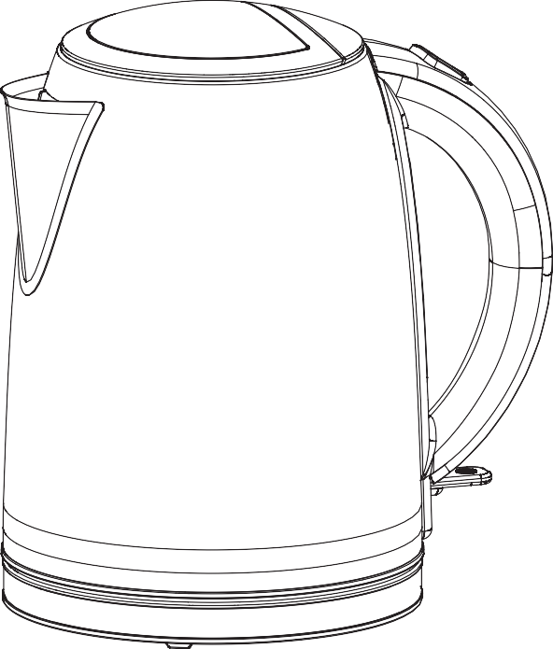
GJK501R-20/GJK501B-20/GJK501G-20 GJK501SG-20/GJK501SS-20
Electric kettle
User Guide 220-240V~ 50/60Hz 2550-3000W
IMPORTANT: RETAIN FOR FUTURE REFERENCE

2

About this guide
We’ve written this manual to help you get the most from your electric kettle. Please hold on to it for future reference.

WARNINGS:

THIS PRODUCT WAS DESIGNED AND MANUFACTURED TO MEET STRICT QUALITY AND SAFETY STANDARDS. THERE ARE, HOWEVER, SOME OPERATIONAL PRECAUTIONS YOU SHOULD BE AWARE OF.
CAUTION. RISK OF SCALDING. DO NOT OPEN LID WHILST KETTLE IS HOT. BE CAREFUL WHEN POURING BOILING WATER FROM YOUR KETTLE AS THIS CAN RESULT IN INJURY. ENSURE THE SWITCH IS NOT OBSTRUCTED OR THE KETTLE WILL NOT SWITCH OFF.
- Read all warnings & instructions in this manual to ensure you get the best out of your product.
- Avoid outdoor use. This appliance is for household use only.
- This appliance can be used by children aged from 8 years and above if they have been given supervision or instruction concerning use of the appliance in a safe way and if they understand the hazards involved. Cleaning and user maintenance shall not be made by children unless they are older than 8 and supervised. Keep the appliance and its cord out of reach of children aged less than 8 years.
- ASDA does not recommend allowing children to operate this appliance.
- This appliance can be used by persons with reduced physical, sensory or mental capabilities or lack of experience and knowledge if they have been given supervision or instruction concerning use of the appliance in a safe way and understand the hazards involved.

3

- Children shall not play with the appliance.
- If the supply cord is damaged, it must be replaced by the

in order to avoid a hazard.
- Before connecting the kettle to the power, check the voltage shown on the appliance base corresponds with the voltage in your home. If it doesn’t, contact your dealer and don’t use the kettle.

- Extreme caution must be used when moving an appliance containing hot water.
- Unplug the kettle when not in use and before cleaning. Allow to cool.
- Kettle is only to be used with the stand provided.
- Do not touch hot surfaces. Use the handle.
- Do not immerse the electrical parts of the appliance in water or other liquids. Never hold the appliance under running water.
- Keep away from harsh or abrasive cleaning agents or solvents.
- This appliance is only suitable for domestic use and it is not designed for commercial purpose.
- Do not use if the kettle, base or cord is damaged. 18.
19.
- Avoid boiling without water as this can damage the heating elements.
- Always make sure the lid is closed while the kettle is boiling and avoid contact with the steam coming from the spout.
- When pouring don’t tip the kettle too fast. Always use the handle and don’t touch the body (as this can get very hot).
- The cord shouldn’t hang over the edge of a table or counter, or touch a hot surface.

4

- Keep away from hot gas and electrical burners.
- Do not use attachments not recommended by the manufacturer.
- Don’t use the kettle for anything other than its intended use.
- Please don’t dismantle. If a fault occurs have the kettle inspected in a qual
for
- WARNING! Avoid spillage on the connector.
- Regarding the instructions for cleaning surfaces in contact with food, please refer to chapter “How to clean the filter "&“How to clean the kettle”.
- WARNING! Misuse may lead to injury.
- WARNING! The heating element surface is subject to residual heat after use.

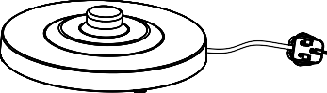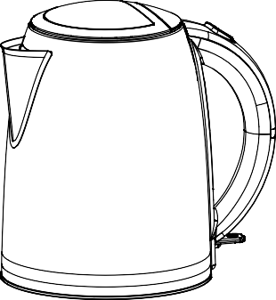
You should have
Electric kettle & power base

5

How to…
…recognise the parts of your electric kettle

Lid
Lid button

Handle

Level indicator

On / Off switch

Power cord

Plug

Power base

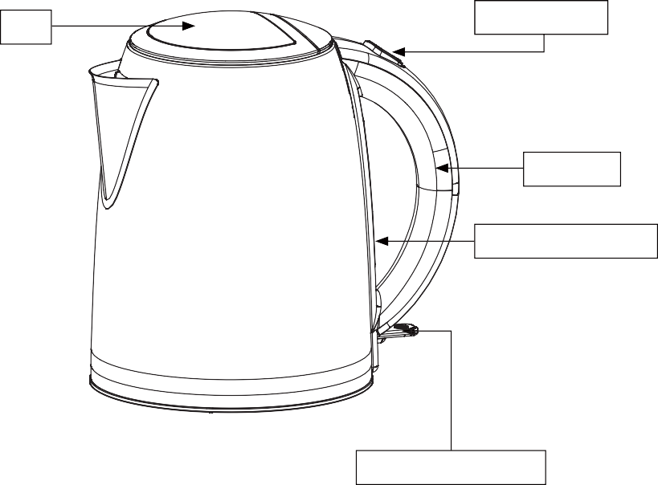
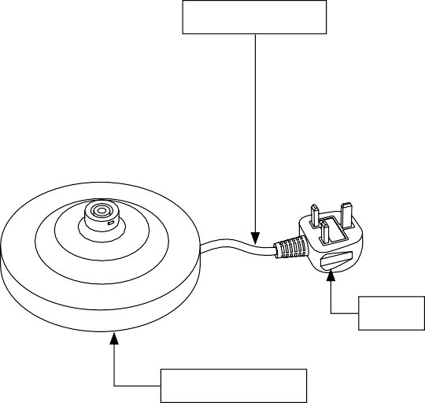
6

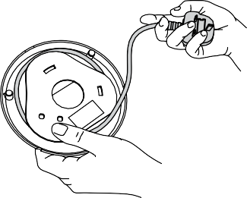
How to…
…plug the power base in

1. Unwind the cable from the tabs under- neath the power base.

2. Fit the power cable firmly into the base slot, so it's stable.
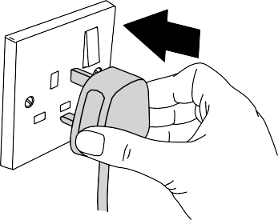

3. Pop the plug into an electrical socket and turn the power on.

7

How to…
…use your electric kettle
Please note
If you’re using the kettle for the time, we recommend cleaning before use by boiling and discarding a full kettle of water twice. Then simply wipe the surface down with a damp cloth.
If you accidentally boil the kettle when it’s empty, the kettle will switch off automatically. If this happens, allow the kettle to cool before it with cold water and re-boiling.
You can shut off the power whilst the kettle is boiling by pushing the on/off switch up.

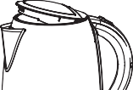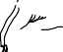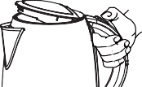
Two step lid:
1. Push the button on the top of the handle and the lid will pop up. To make the kettle easier to fill, you can also lift the lid further open to a vertical position.

Fill the kettle with water to your desired level
Do not exceed the MAX marker on the water gauge.
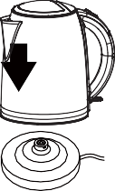
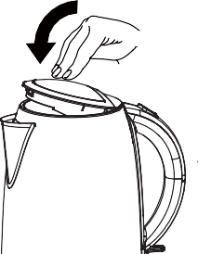

2. The inside of your kettle is equipped with a'1 CUP' and′2 CUP' indicator. If you only wish to boil enough water for one or two cups, please fill your kettle with water to just above the appropriate level. Filling the kettle below the one cup mark can overheat the element and cause damage.

3. Be sure to close the lid properly or the kettle will not switch off.
Place kettle onto the base, making sure it’s seated properly.

8

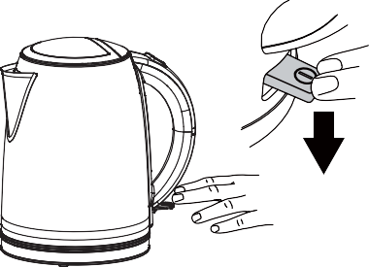

4. Push the switch on the back of the kettle down to boil. This will light up to let you know boiling has begun.
The kettle will automatically switch off once the water has boiled, so you don’t need to worry.
How to…
…de-scale your electric kettle

Your kettle should be de-scaled regularly, depending on how often you use it and how hard your water is. Excessive scale can cause the kettle to switch off before boiling and may damage the elements, affecting your warranty.
To de-scale, simply purchase an all-purpose de-scaling product suitable for your kettle and follow the instructions on the pack. Ensure the electrical connections are completely dry before using the kettle.
How to…
…clean the filter

Make sure the device is disconnected from the power outlet, and the kettle is empty and completely cool.
- To clean the filter, remove it by carefully pushing the filter tab inwards.
- Wash in warm, soapy water and rinse thoroughly.
- Refit the filter and ensure it clicks back into place (unless the filter is fitted correctly, the kettle lid may not close and lock securely).

9

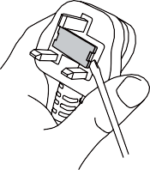
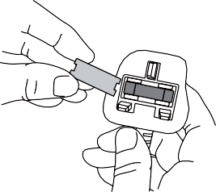
- Only use a 13 amp fuse.
- To change the fuse, place a screwdriver into the recess of the plug cover and pull the fuse holder upward until it’s free.
- Slide the fuse out and pop in the replacement.
- Slot the fuse holder back into the recess and push down until it locks into place.
How to…
…change the fuse

How to…
…clean the kettle

Make sure the device is disconnected from the power outlet, and the kettle is empty and completely cool.
To clean the kettle body, simply wipe with a damp cloth (do not use abrasive cleaners).

10

If for any reason you’re not

our product, return it within 100 days with your proof of purchase, and we’ll give you an exchange or a refund.
UK Mainland stores only.
Excludes franchises.

pack furniture, which can’t be returned if it has been partly or fully assembled unless faulty or mis-described. Also excludes mattresses, which can’t be returned for hygiene reasons once used, unless faulty or mis-described.

Customer services information
If you have any problems, need more information or spare parts, or even just some advice on your product, then don’t hesitate to contact customer services at the telephone number or address shown opposite. N.B. When calling or writing please have your product site code handy.
Call
0800 952 0101
Write
ASDA, Leeds LS11 5AD

GJK501R-20/GJK501B-20/GJK501G-20/
Product name:
GJK501SG-20/GJK501SS-20
Electric kettle
15A.09.22.110/15A.09.22.111/15A.09.22.112/
Product site code: 15A.09.22.113/15A.09.22.114
11

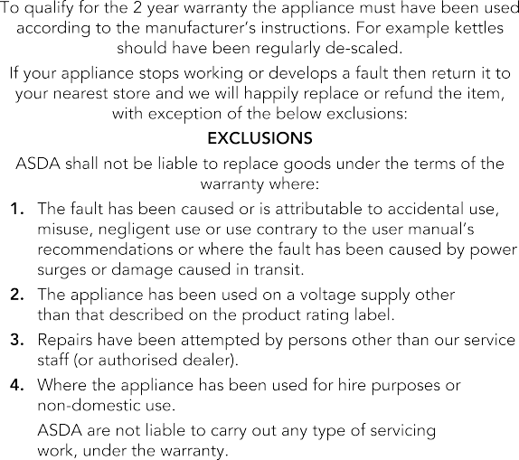
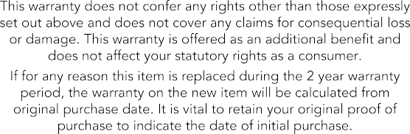
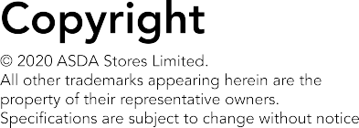
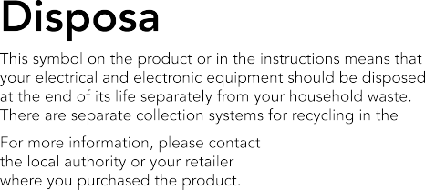

UK.

Produced for ASDA, Leeds LS11 5AD/ASDA,
Antrim BT41 4GY.

