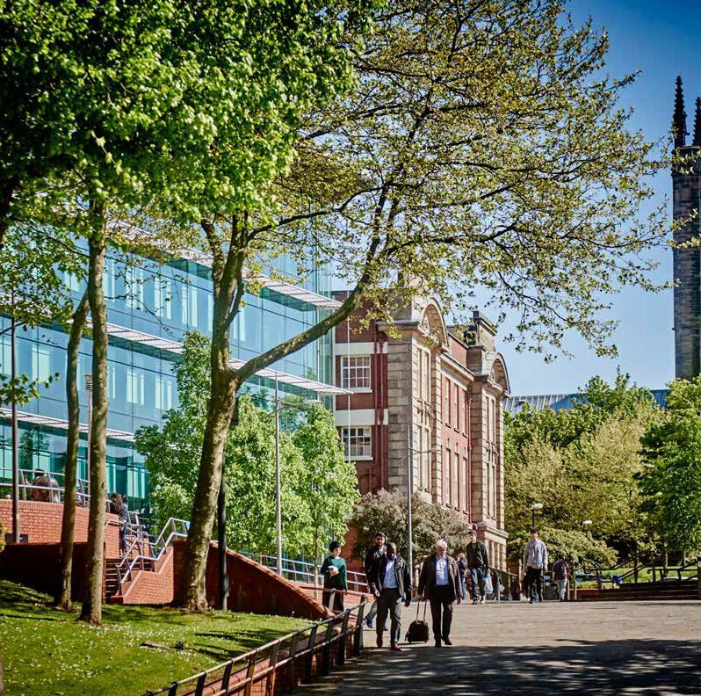




Snow and Ice Process –
Estates & Facilities

1

2


1. Purpose
2. Scope
3. Winter Maintenance Priorities
4. Public Highways
5. Operational Arrangements
6. Dynamic Risk Assessment
7. Limitations
8. Monitor and Review

PROCEDURE Snow and Ice Management Process

- Purpose
The University is committed to maintaining, so far as is reasonably practicable, safe access and egress across its campuses during periods of snow and ice. This process sets out the arrangements for winter maintenance activities and the prioritisation of resources during adverse weather conditions.
- Scope
This process applies to all University-managed external pedestrian routes, building entrances, steps, emergency escape routes, and vehicle access areas.
- Winter Maintenance Priorities
During periods of snow and ice, Facilities Services will prioritise the inspection, treatment, and clearance of the following areas:
Priority 1 Areas
- Main pedestrian routes and internal perimeter footpaths.
- Primary entrances and exits to university buildings.
- Building entrance steps and access ramps.
- Emergency escape routes and fire exits.
- Pedestrian routes linking buildings with car parks and public transport access points.
- Designated accessible routes for disabled staff, students, and visitors.
Priority 2 Areas
Subject to available resources and prevailing weather conditions:
- Secondary pedestrian routes.
- Additional building entrances.
- Internal vehicle routes and car park access roads.
- Pedestrian routes through car parks.
- Public Highways
At certain campuses, public highways run through or adjacent to university property and provide key access routes to university buildings and car parks.
Responsibility for winter maintenance of adopted public highways rests with the relevant Local Authority. Priority 1 highway gritting routes will be treated by the Local Authority in accordance with its winter maintenance programme.
Where operationally feasible and where access is required to University facilities, Caretaking staff may undertake additional treatment of local access roads within the campus boundary. Such activity will only be carried out where it is safe to do so and resources permit.
- Operational Arrangements
Caretaking staff normally commence duty from 6:30am. Due to the unpredictable nature of winter weather conditions, the University cannot guarantee specific treatment or clearance times.
The timing and frequency of winter maintenance activities will be determined by:
- Weather forecasts and prevailing conditions.
- Severity and duration of snow or ice.
- Staffing levels and resource availability.
- Campus operational requirements.
- Health and safety considerations.
- Dynamic Risk Assessment
During periods of severe weather, managers and operational staff will undertake dynamic risk assessments to determine priorities and allocate resources appropriately.
Priority will be given to:
- Areas with high pedestrian traffic.
- Accessible routes.
- Emergency access and egress routes.
- Main building entrances.
- Routes supporting essential University operations.
Where necessary, Security staff may assist with gritting and snow clearance activities outside normal working hours to help maintain safe access to priority areas.
- Limitations
Whilst every reasonable effort will be made to treat and clear affected areas, the University cannot guarantee that all routes will always remain free from snow or ice.
Staff, students, contractors, and visitors are expected to take reasonable care during adverse weather conditions and to use designated treated routes whenever possible.
- Monitoring and Review
This process will be reviewed periodically to ensure that arrangements remain effective, proportionate, and compliant with relevant health and safety legislation and University procedures.

Version | V2 | Author / Owner | Sarah Bowers – Facilities Manager
Approved Date | Aug 2026
Review Date | Aug 2028

