




PAT Testing Process – Student
Accommodation

1

2


1. PAT – Student Accommodation
2. Why do we carry out PAT Testing
3. What will the University do
4. Student responsibilities
5. How to check your electrical equipment
6. If you find a problem
7. Request for PAT Testing
8. Confiscation of items
9. Contact us

PROCESS

- Portable Appliance Testing (PAT) in Student Accommodation

This guidance applies to all portable electrical equipment used in university accommodation, including appliances provided by the University and any personal electrical items that you bring with you.

- Why do we carry out PAT testing?
Your safety is important to us. As part of our legal responsibility to provide a safe living environment, we regularly check electrical equipment to help reduce the risk of electric shock, injury, and fire.

PAT testing (Portable Appliance Testing) involves checking electrical appliances to make sure they are safe to use. This includes a visual inspection as well as electrical testing where required.

Because many students live in the same building, a fault with one appliance could quickly affect others and potentially cause a fire. PAT testing helps us identify and remove unsafe equipment before it becomes a risk.

If you are an international student, please make sure any electrical equipment you bring to campus is suitable for use in the UK. All appliances should be used with a UK three-pin plug or an approved UK adapter.

- What we will do
The University will:
- Carry out annual PAT testing on electrical appliances supplied in your accommodation.
- Give advance notice when access to communal areas is required for testing.
- Clearly label tested appliances to show whether they have passed or failed and when they were tested.
- Remove and replace University-owned appliances that fail the safety checks where appropriate.
- Remove any personal electrical equipment that has not been tested or is considered a fire or safety risk. These checks may form part of accommodation inspections carried out between January and March each year.

- What you need to do
As a resident, you are responsible for:
- Bringing electrical equipment that meets UK safety standards.
- Ensuring any appliances you bring are safe and in good working condition.
- Regularly checking your electrical equipment for signs of damage.
- Reporting any damaged or faulty electrical equipment as soon as possible.
- Stopping use of any appliance that may be unsafe until it has been checked.
- Not using any prohibited electrical items in university accommodation.

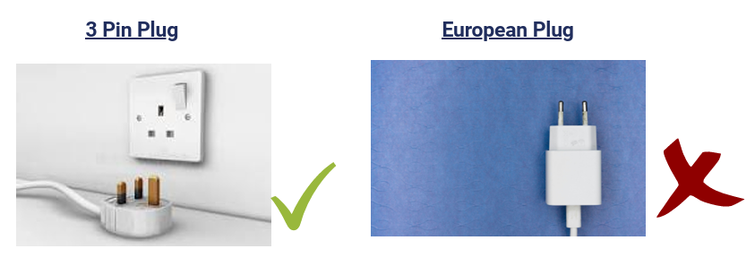

- How to check your electrical equipment
Before using an appliance, take a few moments to check that it is in good condition. Look out for:
- Frayed, damaged, or exposed cables.
- Cracked plugs or bent plug pins.
- Damage to the outside casing of the appliance.
- Loose parts or missing screws.
- Signs of overheating, such as burn marks, melting, discolouration, or unusual smells.
- Equipment that has become wet or damaged.
- Problems with power supply or appliances that work intermittently.

- If you find a problem
If you notice any of the issues listed above:
- Stop using the appliance immediately.
- Unplug it if it is safe to do so.
- Report the issue through the University's repair reporting process.
- Do not use the appliance again until it has been checked and confirmed safe.

- Request for PAT Testing
Upon you arrival if you would like any of your appliances testing contact the accommodation team and we can arrange for this to be completed, if this needs to be carried out by an external company a charge will be allocated for this to be completed.

- Confiscation Process
If a member of staff enters your room for maintenance work, a security-related issue, or as part of a mid-term accommodation inspection and identifies an electrical appliance that appears unsafe, presents a potential fire risk, or is a prohibited item, this will be reported to the Accommodation Team.

Where necessary, a member of the Security Team will attend your room and remove the item to ensure the safety of residents and the building. A calling card will be left in your room detailing:
- The item that has been removed.
- The reason for its removal.
- The name of the staff member or team responsible for removing it.

Confiscated items will be stored securely and can normally be collected at the end of your accommodation licence period. If you leave accommodation earlier, arrangements can be made for you to collect the item before your departure, where appropriate.

This process helps us maintain a safe living environment for all residents.

- Contact Us
If you have any queries, please contact the local accommodation team and they will provide you with any assistance or guidance you may require.

City – cityaccommodationhub@wlv.ac.uk
Walsall – walsallhub@wlv.ac.uk

Version | V1 2026-27 | Author / Owner | Alison Morris  Hub Manager
Approved Date | August 2026 | Approved By | Bec Woolley  Business Support and Quality Assurance Manager
Review Date | August 2028 | Approved By | Bec Woolley  Business Support and Quality Assurance Manager

