Annual Progress Review (APR) 2026/27
Dear Postgraduate Researchers,
This year, we are introducing a new approach to Annual Progress Reviews (APRs).
These changes have been shaped by feedback from postgraduate researchers and staff, alongside a review of practices across the University and insights gained from our most successful PRES initiatives. Many postgraduate researchers told us that, although APRs play a valuable role in supporting doctoral progression, the process could at times feel overly bureaucratic and isolating, placing too much emphasis on paperwork and not enough on meaningful development and support.
Our aim is to create an APR process that remains academically rigorous while also supporting researcher development, peer learning, confidence-building, and community.
This guide explains what the new format involves and answers some common questions.
Why are APRs changing?
PGRs told us that they wanted:
- Greater opportunities to meet and learn from other researchers
- Clearer expectations
- Less administrative burden
- More developmental conversations
- More consistency across faculties
The new approach has been designed to respond directly to this feedback while ensuring that progression decisions continue to meet University and sector requirements.
What is the purpose of an APR?
Your APR is an opportunity to:
- Reflect on your progress
- Receive constructive academic feedback
- Discuss your next steps
- Identify any support you may need
- Review your professional development
- Demonstrate how your research is progressing
The APR is designed to support your development as an independent researcher.
What is different this year?
Most APRs will now take place through cohort-based review events.
This means you will:
- Meet other PGRs who are at a similar stage
- See examples of research from across the University
- Develop presentation and communication skills
- Participate in a shared academic event
- Receive an individual and confidential assessment outcome
Progression decisions remain individual and confidential, but elements of the review process will now take place alongside other researchers.
What will happen on the day?
A typical APR Day will include:
Welcome session
An introduction to the day and an overview of expectations.
Research presentations
Depending on your stage of study, this may involve:
- A poster presentation
- An oral presentation
- A recorded presentation
You will also have the opportunity to hear about the work of other researchers.
Poster and networking session
This provides an opportunity to:
- Discuss research with peers
- Meet researchers from other disciplines
- Share ideas and experiences
- Build your research network
Individual assessment discussion
You will have an individual discussion with your assessors.
During this conversation you should discuss:
- Progress since your last review
- Research design and methodology
- Challenges encountered
- Development and training undertaken
- Plans for the next stage of your research
What will I need to do?
The exact requirements depend on your stage of study.
Full time - PhD
Year 1: Poster Presentation
You will prepare a poster presentation outlining:
- Your research topic
- The rationale for your research
- Research questions
- Early progress
- Plans for the next phase of study
The focus is on project development and establishing a strong foundation for doctoral study.
Year 2: Progression Review
You will submit:
- A substantial written submission
- An oral presentation
This review focuses on progression towards doctoral-level research and provides an opportunity for detailed academic feedback.
Year 3: Recorded Presentation
You will provide:
- A recorded presentation
- A short-written reflection
The emphasis is on:
- Progress towards completion
- Writing strategy
- Planning for submission
Year 4: Pre-Submission Review
This stage focuses on:
- Thesis completion
- Submission planning
- Viva preparation
- Readiness for examination

Part time - PhD
Year 1: Progress Meeting
- Plans for the next phase of study
Year 2: Poster Presentation
You will prepare a poster presentation outlining:
- Your research topic
- The rationale for your research
- Research questions
- Early progress
- Plans for the next phase of study
The focus is on project development and establishing a strong foundation for doctoral study.
Year 3: Progress Meeting
- Plans for the next phase of study
Year 4: Progression Review
You will submit:
- A substantial written submission
- An oral presentation
This review focuses on progression towards doctoral-level research and provides an opportunity for detailed academic feedback.
Year 5: Progress Meeting
- Plans for the next phase of study
Year 6: Recorded Presentation
You will provide:
- A recorded presentation
- A short-written reflection
The emphasis is on:
- Progress towards completion
- Writing strategy
- Planning for submission
Year 7: Progress Meeting
- Plans for the next phase of study
Year 8: Pre-Submission Review
This stage focuses on:
- Thesis completion
- Submission planning
- Viva preparation
- Readiness for examination

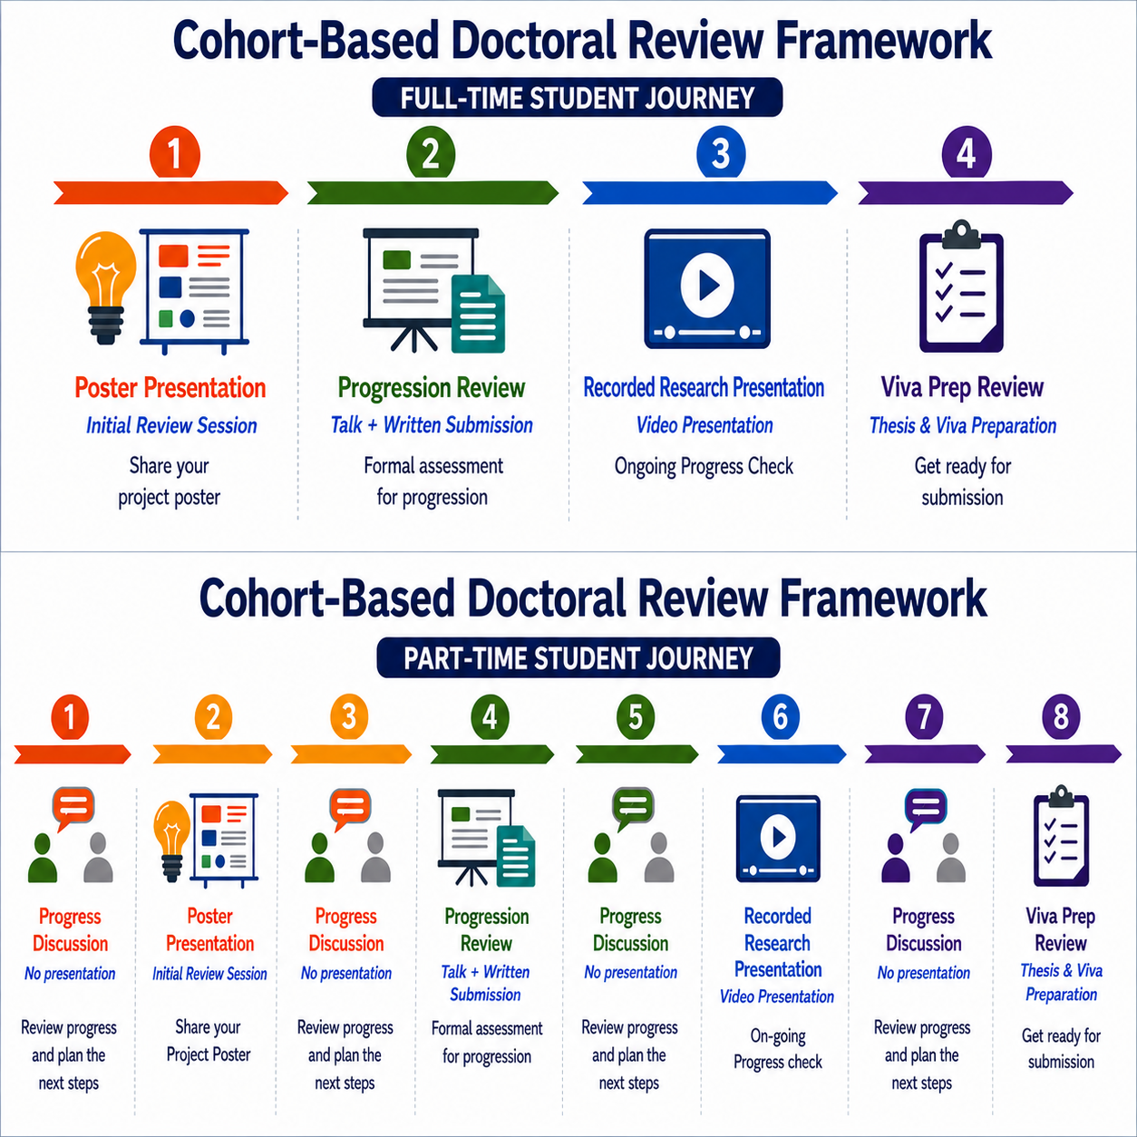

Full time - MPhil
Year 1: Poster Presentation
You will prepare a poster presentation outlining:
- Your research topic
- The rationale for your research
- Research questions
- Early progress
- Plans for the next phase of study
The focus is on project development and establishing a strong foundation for MPhil study.
Year 2: Progression Review
You will submit:
- A substantial written submission
- An oral presentation
- Discuss submission planning
- Viva preparation
- Readiness for examination
This review focuses on progression towards MPhil level research and provides an opportunity for detailed academic feedback.

Part time - MPhil
Year 1: Progress Meeting
- Plans for the next phase of study
Year 2: Poster Presentation
You will prepare a poster presentation outlining:
- Your research topic
- The rationale for your research
- Research questions
- Early progress
- Plans for the next phase of study
The focus is on project development and establishing a strong foundation for MPhil study.
Year 3: Progression Review
You will submit:
- A substantial written submission
- An oral presentation
This review focuses on progression towards MPhil level research and provides an opportunity for detailed academic feedback.

Year 4: Pre-Submission Review
This stage focuses on:
- Thesis completion
- Submission planning
- Viva preparation
- Readiness for examination

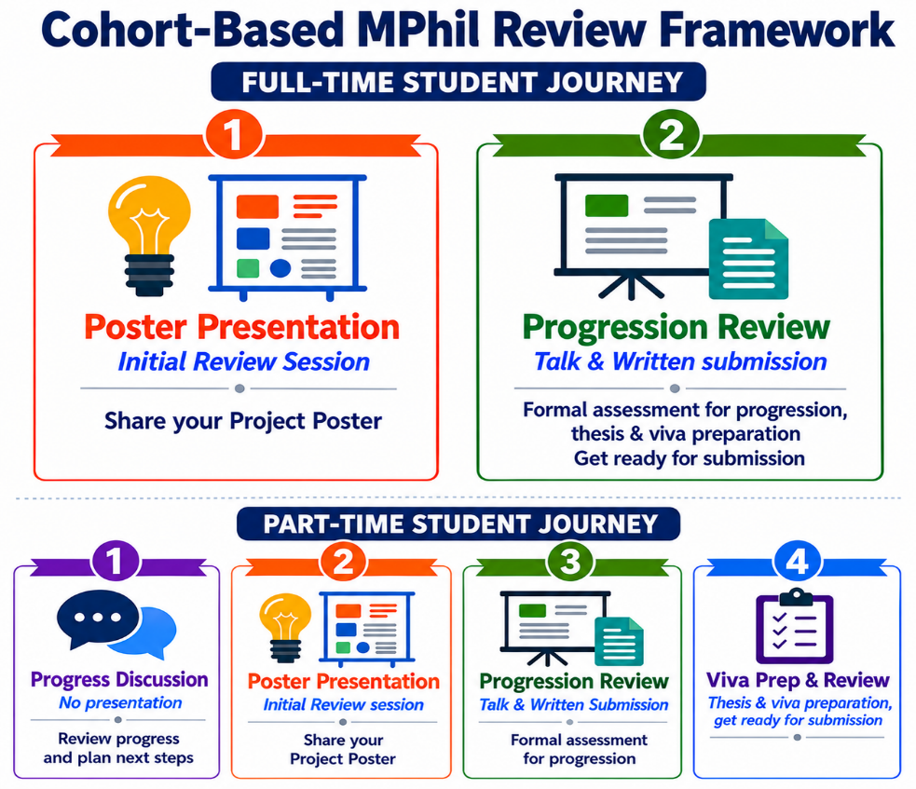

Will everybody see my assessment result?
No.
Although some activities take place as part of a shared event, progression discussions and outcomes remain confidential.
Your assessors will make an individual judgement regarding your progress, and only you and the relevant University staff will receive that outcome.

I feel nervous about presenting. What support is available?
Many researchers feel nervous about presenting their work.
The new APR model has been designed to help build confidence gradually throughout your doctorate.
Support will include:
- Guidance materials
- Presentation advice
- Training opportunities
- Clear expectations in advance
- Opportunities to learn from peers
Remember that APR presentations are not intended to be polished conference keynotes. They are opportunities to discuss your ongoing research and receive constructive feedback.

What if I am a part-time student?
Part-time researchers remain an important part of our research community.
The assessment requirements will reflect your stage of study and progression route. You will have the same number of presentation activities across your doctoral journey as full-time students, although these will be spaced differently.

What if I need reasonable adjustments?
If you have a disability, health condition, caring responsibilities, or any other circumstance that may require reasonable adjustments, the University's Accessibility, Disability and Inclusion Team is available to provide advice and support. They can also guide you through the process of applying for a Tutor Awareness Sheet (TAS):
https://www.wlv.ac.uk/current-students/student-support/accessibility-disability--inclusion-team/tutor-awareness-sheet/
The University is committed to working with you to ensure that appropriate support and reasonable adjustments are put in place to help you succeed in your studies.
What if I cannot attend?
The APR is an important and mandatory part of the doctoral journey.
If exceptional circumstances arise, please contact RDSS as soon as possible so that advice and support can be provided.
Researchers on an approved Leave of Absence will normally attend the next available APR following their return.
The APR is a formal assessment process with defined outcomes, and continued registration is contingent on satisfactory progress. Failure to attend without a valid reason will result in a Proceed with Caution outcome and may affect your completion date or, in some cases, lead to withdrawal from the programme. It is therefore important that you engage fully with the process and submit your assessment by the required deadline.
How does training fit into the APR?
The APR is linked to your ongoing researcher development.
As part of the review process, you will be asked to reflect on:
- Development activities undertaken
- Skills gained
- Your Personal Development Plan (PDP)
- Future development goals
For new researchers, completion of mandatory induction and Essential Skills activities forms an important part of this discussion.

What are the benefits of the new approach?
We hope the new model will:
✅ Create more opportunities to connect with fellow researchers
✅ Reduce isolation
✅ Support presentation and communication skills
✅ Make expectations clearer
✅ Reduce administrative burden
✅ Provide a more consistent experience across faculties
✅ Celebrate postgraduate research and researcher achievement
Most importantly, we want APRs to become a valuable developmental milestone rather than simply an administrative requirement.

Frequently Asked Questions
Is this a conference?
Not exactly. It is an academic review event, but it incorporates some conference-style activities because these help develop important researcher skills.
Do I have to attend the whole event?
Yes. The event forms part of the APR process and community-building activities.
Will my supervisor assess me?
APRs include independent academic scrutiny. Your supervisor's role and the role of assessors will be explained in the guidance provided before your review.
What if my research is not going to plan?
That is precisely why the APR exists. The discussion is an opportunity to identify challenges, explore solutions, and access support.
Do I need to compete with other researchers?
No. APRs are not competitive exercises. Every project is different, and assessments are based on your individual progress and stage of study.
Can I attend even if I am not being assessed?
Yes. We encourage PGRs to attend and engage with the wider research community wherever possible.

Looking Ahead
These changes form part of a wider programme of enhancements to the postgraduate research experience, developed in response to PGR feedback. Our goal is not only to support successful completion but also to create a stronger, more connected and more supportive research culture.
We will continue to gather feedback on the APR process and use your experiences to shape future improvements.

You told us. We listened. We acted. And we'll keep listening.

